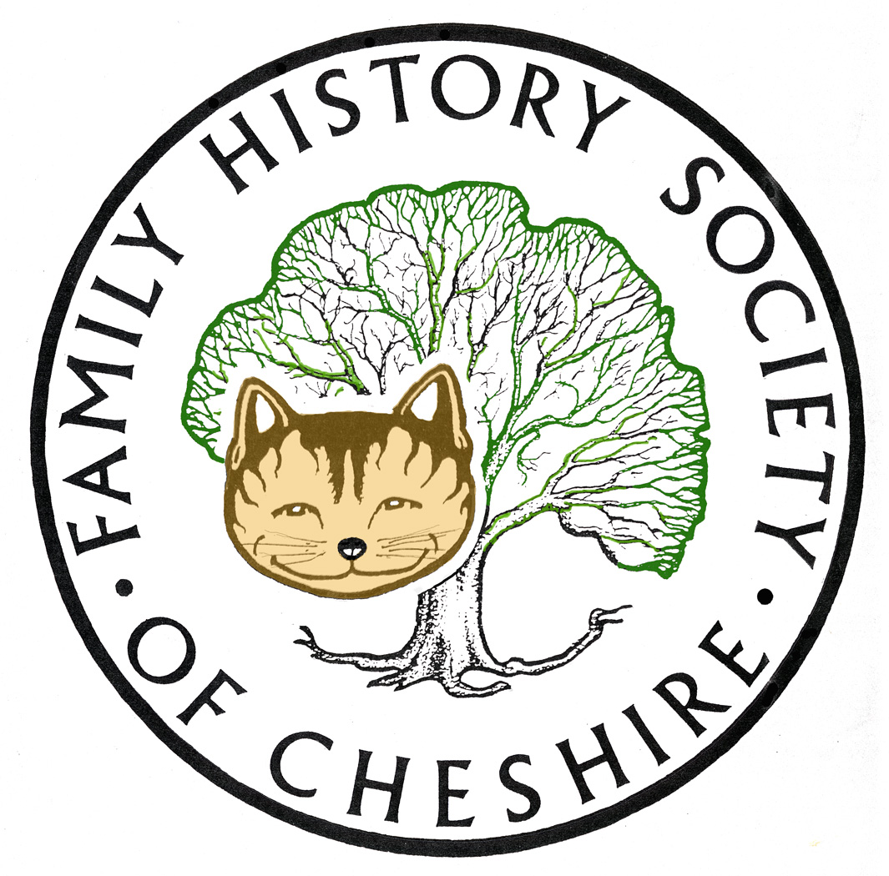
TAMESIDE GROUP NEWSLETTER
September 2013

Next Month:

Instead of our planned speaker Jill Marshall, who has now moved to Surrey I have booked Joseph O’Neill, a professional writer, who will talk about “The Anatomy of an Irish Ghetto”. Although based around Ancoats many features will be common to Irish communities elsewhere.

In November John Creer will be coming along to talk about DNA for family historians and Surname Projects. I’m really looking forward to this since I have just sent off my own DNA

Heritage Open Days: http://www.heritageopendays.org.uk/directory/laa/Tameside 31 venues or walks in Tameside. New this year is St Ann’s church in Ashton, the first Catholic Church in Tameside to open for heritage weekend which will include material on display about the Murphy Riots in 1863.

Cheshire BMD – major milestone reached, Bob Kirk now tells me that all the Mothers’ Maiden Names for all the pre Tameside sub registration districts are now complete.

FreeBMD – have added 3,662,485 records since 20 April this year. Have a look at their progress page: http://www.freebmd.org.uk/progress.shtml

Soldiers Wills online: https://www.gov.uk/probate-search#before-you-start
The last wishes of thousands of soldiers who died during the First World War and were unseen for a century are being made available online.
The handwritten wills of 230,000 British Empire soldiers have been placed on a new website allowing families and historians to view them for the first time. About 5% of the wills contain a treasure trove of personal letters penned by the soldiers and intended for loved ones back home but which were never posted because they contained sensitive information. Instead, those letters have lain alongside the writers' wills in row upon row of sealed archive boxes for 100 years, until now.

ARA Archives Record Association UK and Ireland – National Digitization Consortium
Now the high-level contracts are signed, all archives which declared an interest to take part are being contacted about their formal sign-up to the deal. The National Digitisation Consortium was an Association of Chief Archivists in Local Government inspired initiative and has been an active but complex project since the merger which formed the ARA. In the first project under the Consortium framework, 120 English and Welsh archives are expected to come together to achieve the digitisation of pre-1914 school registers. Millions of names will be searchable.
ARA and brightsolid are now determined to move the project forward as quickly as possible.

The National Archives Podcasts: including Hearth Tax, Brick Walls and Lost Ancestors, DNA for Family historians, Migration and Searching your Merchant Seamen. These are audio versions of their talks programme: http://media.nationalarchives.gov.uk/index.php/category/family-history/

FindMyPast: http://www.findmypast.co.uk/content/news/2013 this is what has been added since our last meeting here in June

- Canadian records unveiled world wide subscription needed
Posted: 19 August 2013
- 125 million world newspapers released world wide subscription needed
Posted: 07 August 2013
- New Worcestershire parish records added
Posted: 29 July 2013
- Searching for living relatives now included
Posted: 19 July 2013
- New Royal Naval Division Service Records 1914-1920
Posted: 11 July 2013
- Two million new Hertfordshire parish records added
Posted: 01 July 2013
- We've added 1.2 million new Welsh parish records
Posted: 27 June 2013
- British newspapers updated
Posted: 20 June 2013
- London volunteer soldier records 1859-1955 added
Posted: 17 June 2013
- Lincolnshire parish registers published online
Posted: 13 June 2013

Their British Newspaper Collection now includes the Manchester Evening News up until 1917, so you will find many articles about local First World War Casualties.

FamilySearch and Ancestry.com Working Together to Make More Records Available Online
September 6, 2013 By FamilySearch Blog: https://familysearch.org/blog/en/

FamilySearch and Ancestry.com recently announced a joint agreement to begin a 5-year effort to digitize and index more than 1 billion records from around the world. FamilySearch is excited to be a partner in this significant project that will provide greater accessibility to these valuable records.

Family Search also stopped support and downloads of their Personal Ancestral File family tree software from 15th July this year. Please see their website to learn more about the three alternative software programmes they recommend that will work with their Family Search online trees.

Ancestry is turning off their OLD SEARCH facility this Autumn, please see this page from Ancestry Insider showing you how to get the best from their New Search Facility: Old Search in New Search clothing:
http://ancestryinsider.blogspot.co.uk/2013/07/old-search-experience-in-new-search.html

Ancestry’s biggest scoop over the Summer was their addition of non conformist records previously on available via BMDRegisters.co.uk or the genealogist.co.uk These include Hyde Chapel, Old Chapel Dukinfield, Dukinfield Moravians and Albion Congregational from their inception until around 1837. Also Railway Records, Clandestine Marriage Records and Some Surrey and Liverpool Parish Records

Gay Oliver: gayjoliver@gmail.com 11 September 2013

