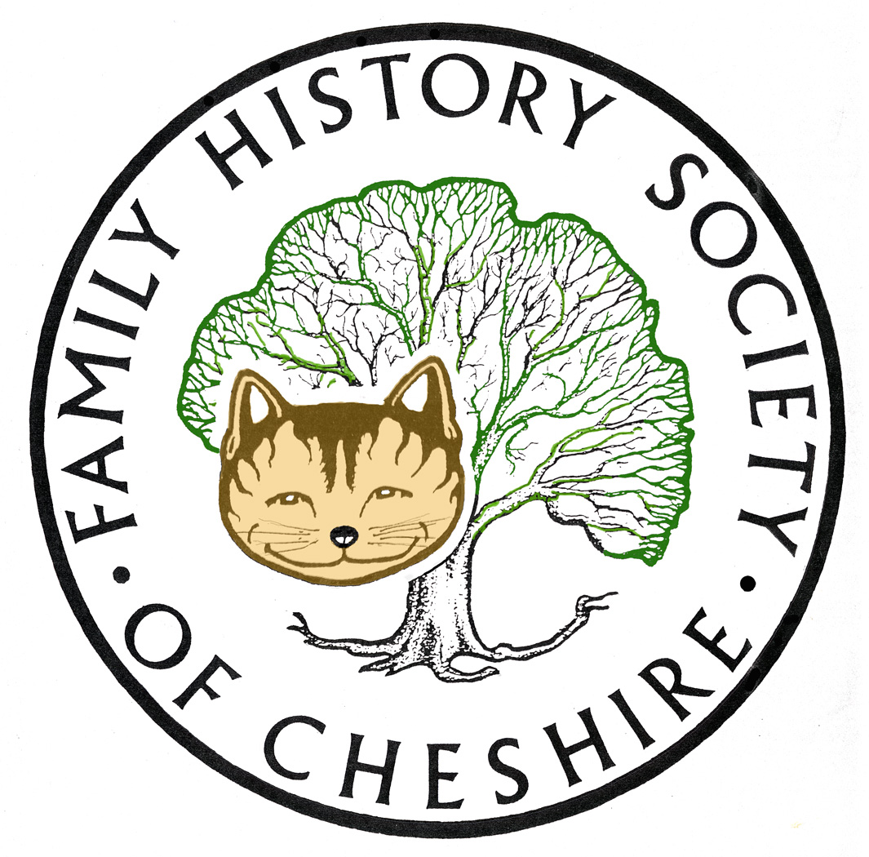
TAMESIDE GROUP NEWSLETTER
SEPTEMBER 2012

Library Closures Consultation: Keeping my fingers crossed, but not holding out much hope. The results of the consultation go to committee in a couple of week’s time.

Cheshire BMD was updated on 20 August as follows:
Births:
Replaced 2,639 for Ashton and Mossley, registers at Tameside (1937-1961) to add mother's maiden name and change the reference number prefix from MOS to A&M
Replaced 80,559 for Ashton Town, registers at Tameside (1837-1905) to add mother's maiden name
Replaced 18,236 for Mossley, registers at Tameside (1897-1937) to add mothers’ maiden name. This means that all the mothers’ maiden names until at least 1900 are complete, apart from about three years 1897-1900 for Stalybridge.

Family Search: Old Family Search is no more, so like it or not we will have to learn how to use their new site to best advantage. I have re-written a research quide, which is available under Research Resources on our website: fhsc.org.uk:

Parish Registers and New Family Search and the I.G.I. rewritten August 2012
Ancestry: I have also begun to use their NEW SEARCH screens more and more, particularly when using the Archives Library’s Library Edition. The following blog entry describes how you can get the most out of their NEW SEARCH: http://michaelhait.wordpress.com/2012/06/19/new-search/

Programme for 2012 - 2013:

10th October – Joan Irving will talk about the importance of using timelines to understand your ancestor’s Lives.

14th November – Adrian Brown ‘From Royalty to Ruin’ – the story of his ancestor Seth Backhouse.

12th December – Quiz, Social and Potato Pie Supper.

9th January – Brian Hallsworth ‘From the Old Wives Mouth’ – professional speaker who came last Christmas to talk about ‘In the Bleak Midwinter’.

13th February – Visit to the Local Archives Centre to view the Stamford Estates Archives.

13th March – Barbara Foster ‘The Lady Stamford Reminisces’ costumed talk by National Trust Speaker from Dunham Massey.

10th April – Dorothy Bintley will talk about the Family Search Website including Effective Search Techniques and the use of Batch numbers.

8th May – Dr Susan Deal ‘Cleanliness is Next to Godliness’ the Victorian Obsession with Hygiene.

12th June – David Lambert, member of the Metcalfe Society will be coming along to let us know how belonging to a One Named Study Group has helped with his research.

July – I am suggesting a visit to the working Cotton Mill at Queen Mill in Burnley or perhaps to Lancashire Record Office.

Any changes or alterations to our programme will be posted on our Society website: fhsc.org.uk click on Groups and then Tameside. Meetings are held in the Old Chapel schoolrooms, Old Road, Dukinfield, on the second Wednesday of each month (except August), starting at 7.00 pm. £1.50 for members and £2.00 for non members, tea and coffee on arrival.

Gay Oliver: gayjoliver@gmail.com 11 September 2012

