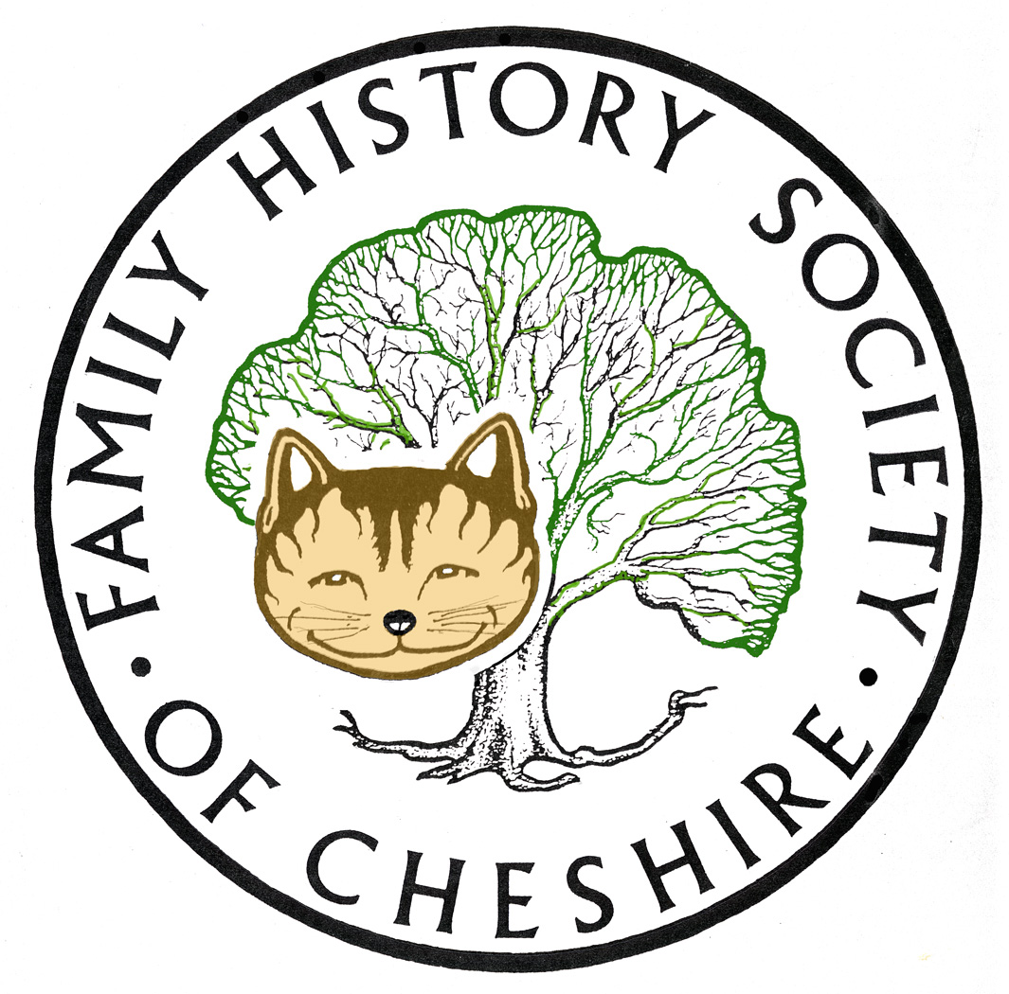
TAMESIDE GROUP NEWSLETTER
October 2015

Don’t Forget to sign up for Lost Cousin’s Newsletter – free and very informative: http://lostcousins.com/ The latest edition contains a very useful article about the best DNA tests and Companies.
Here’s another article worth reading from Family History Daily: http://bit.ly/1hKLMj5 The HUGE Genealogy Mistake will all need to stop making.
Anyone who missed my talk about the Poor Law in Tameside can catch it again at Ryecroft Hall in Audenshaw on Monday 26th October from 7.15pm hosted by Audenshaw Local History Society.
My Heritage. I am rather fed up with this website. I pay around £100 to host my family tree with them, because someone advised that their SMART MATCHES were excellent. They don’t seem much better than those on Ancestry and if you want to look up one of the original documents and use their search facility they want to charge another £6.95 a month to access their databases. Not happy with this since I already subscribe to Ancestry and FindMyPast and also a very small fee of £19 per annum to host my family tree at Tribal Pages. I also pay around £70 per year to host my websites, pay annual subscriptions to a couple of magazines and a couple of Family History Societies. Fortunately I no longer have to send for many BMD Certificates. Consider also the cost of IT equipment, printer ink, paper and Anti Virus software and a pound a month for back up to the cloud. Never mind paying for DNA tests, Family History is no longer cheap, so I am going to concentrate on value for money from now on.
Computers and IT equipment etc: Another moan – there will be good news later in this newsletter. My main gripe is how often things need charging and updating. Everytime I open my PC some software needs updating. The latest one took twenty hours to update 11 of 11 Windows up-dates – ‘do not turn off your computer’. When it finally up-dated: ‘Please update to the latest version of Malware bytes’ and ‘your subscription to Avast anto Virus software is due in two weeks.’ OK Fine! Can I now get down to writing this newsletter – no ‘there are updates to Adobe Air waiting to download’. Next day trying to finish this newsletter. ‘Malwarebytes would like to scan your computer now’, ‘Avast has found thirteen programmes slowing down your computer’ and now, ‘Adobe Reader has up-dates.’
I have also got two charging stations at home now one upstairs and one downstairs for iPod, iPad, Phone and Mifi unit. The phone and mifi need constant feeding with funds online, that’s if their websites don’t freeze and say ‘please try later’. Apple only provide a very short lead for their equipment which means you can’t use them comfortably while they are charging, so I have bought two three metre leads and an extra charging plug, being careful to make sure they are not the cheap ones which set on fire automatically.
I love IT and gadgets more than most, but who says that Computers make you ‘work smart’ and save time!! Also Facebook recently told me that I spend over two hours a day using it – grrh! Guilty, and proves I could be more productive of my time. I won’t even mention Twitter!!
NOW FOR THE GOOD NEWS
Next month, Myko Clelland is coming along to talk to us about their major release this year, ‘The 1939 Register’. Myko is the outreach worker for Find My Past and we are very lucky that he has links with Tameside. The 1939 Register is as it says a register of people who had to apply for Identity Cards at the out break of war. It was compulsory to register and details include occupation and address. It can be regarded as a census substitute. We wont get to see the 1921 census until January 2022, the 1931 was bombed during the Blitz and no census was taken in 1941 because of the War. I, for one, don’t think I will be alive to see the 1951 census, so this will be an important release, hopefully this winter sometime. Make a note in your diary now for November 11.
Look out for Tameside’s new Events brochure listing all their cultural events from October – March 2016. When I can get hold of an electronic copy I will send one to everyone.
FIND MY PAST since last month
http://blog.findmypast.co.uk/fridays/ Releases include some college records and a major release of electoral registers

Ancestry – new collections this month are Irish Civil Registration indexes and a database of Suffragettes arrested.

The FreeBMD Database was last updated on Thu 1 Oct 2015 and currently contains 249,574,602 distinct records (318,100,810 total records). An amazing achievement for the volunteers; nearly a quarter of a billion records.

70 Irish Ancestor Resources: http://crestleaf.com/blog/70-resources-finding-irish-ancestors/
An excellent list for people researching Irish Ancestors

Programme for 2015 - 2016:

November 11 – Myko Clelland from FMP “The 1939 Register”

December 9 – Social - Usual Venue and usual Potato Pie Supper

January 13 – Me Perhaps about iPad Apps and Tribal Pages

February – no meeting

March 9 – Allan Arrowsmith “Denton then and Now”

April 13– tba )

May 11 – tba ) I have some suggestions

June 8 – tba )

July – visit Stockport Hatworks? Or Air Raid Shelters

August 10 Me about Irish Family history Research?

Gay Oliver: gayjoliver@gmail.com 18 October 2015

