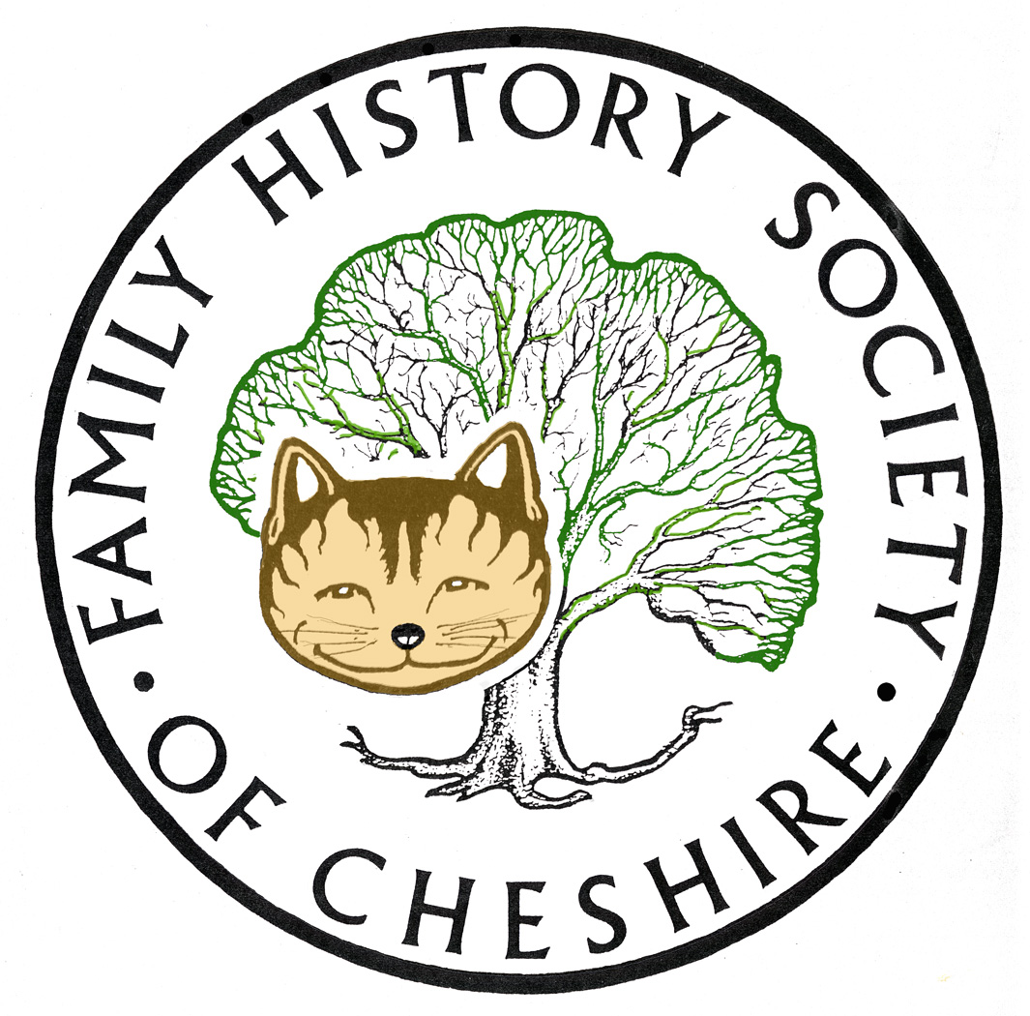
TAMESIDE GROUP NEWSLETTER
OCTOBER 2012

Library Closures Consultation: Sadly the Council’s Option Three went through with no exceptions to their new opening hours for the Archives Centre. They now have fewer opening hours compared with the other surviving town libraries. From 15th October they will open: 9.00am-8.00pm Tuesday, 9.00am-5.00pm Wednesday and Thursday, and 10.00am-3.00pm pm Saturday.

Cheshire BMD was updated on 20 August as follows: 13,493 births for Stalybridge, registers at Tameside (1897-1907) to add mothers’ maiden names. The next up-date witll take these up until 1937.

Find My Past goes world wide. For a limited period and an extra £30 you can now have access to their American, Irish and Australian and New Zealand sites. I am trialling this at the moment to see if the extra databases make this worthwhile. After the trial period the world wide subscription will be £159.95.

Our Society Website has two new sections. Joan Irving, our Society Librarian, has been cataloguing our holdings at our Mobberley Research Centre. If you go to our website: fhsc.org.uk and then click on Mobberley Research Centre there is a menu on the right-hand side showing library holdings. You will find about 20 different indexes itemising the vast array of books, CDs, microfilms and fiche available for visitors to use.

Why not visit our AGM on Saturday. There are full details on our website, but basically there is a talk by Paul Newman from Chester Record Office “The future of our Past in 2022” 10.15 am followed by our AGM. A visit to Knutsford Chapel has been arranged for the afternoon. Elizabeth Gaskell is buried there and there is an exhibition in the adjacent Heritage Centre. For those not wishing to visit the church the Resource Centre will be open.

For Members’ only, our research resources have been moved. You have to be logged in first and then click on
Online Research Resources in the bottom right-hand Members Only menu. Here you will find research guides on various aspects of Family History Research and a couple of newer sections about published family histories, background information and small projects. We’d like to keep adding information here, so think about any contributions you can make.

Programme for 2012 - 2013:

14th November – Adrian Brown ‘From Royalty to Ruin’ – the story of his ancestor Seth Backhouse.

12th December – “My Granddads an Oyez Man” John Parsons arrives in the full regalia of the town crier to the Lord of the Manor of Rode Hall or the official regalia of Nantwich Town to give the talk its full potential. Plus a Potato Pie Supper

9th January – Brian Hallsworth ‘From the Old Wives Mouth’ – professional speaker who came last Christmas to talk about ‘In the Bleak Midwinter’.

13th February – Visit to the Local Archives Centre to view the Stamford Estates Archives.

13th March – Barbara Foster ‘The Lady Stamford Reminisces’ National Trust Speaker from Dunham Massey.

10th April – Dorothy Bintley will talk about the Family Search Website including Effective Search Techniques and the use of Batch numbers.

8th May – Dr Susan Deal ‘Cleanliness is Next to Godliness’ the Victorian Obsession with Hygiene.

12th June – David Lambert, member of the Metcalfe Society will be coming along to let us know how belonging to a One Named Study Group has helped with his research.

July – I am suggesting a visit to the working Cotton Mill at Queen Mill in Burnley or Lancashire Record Office.

Any changes or alterations to our programme will be posted on our Society website: fhsc.org.uk click on Groups and then Tameside. Meetings are held in the Old Chapel schoolrooms, Old Road, Dukinfield, on the second Wednesday of each month (except August), starting at 7.00 pm. £1.50 for members and £2.00 for non members, tea and coffee on arrival.

Gay Oliver: gayjoliver@gmail.com 11 September 2012

