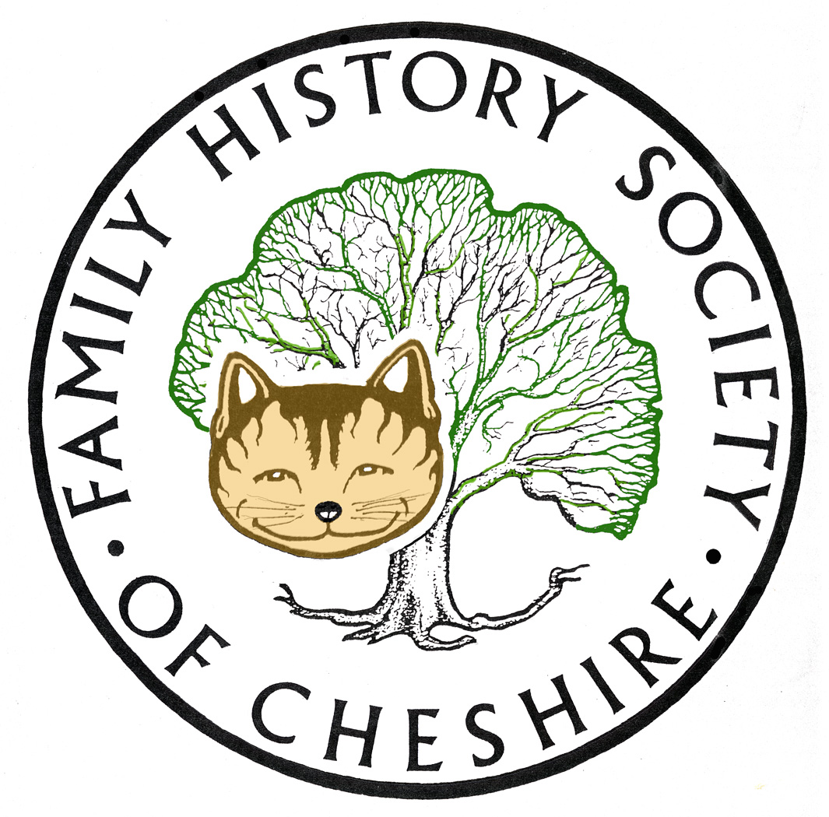
TAMESIDE GROUP NEWSLETTER
November 2016

NEED VOLUNTEERS TO TAKE OVER REFRESHMENTS:

So pleased that Pam Evans, Jenny Lever and Anita Wozniak are now helping with refreshments with a couple of other volunteers in reserve

NEW SOCIETY WEBSITE TO BE LAUNCHED VERY SOON

This new site will be launched very soon. Once it is launched it will have the same address: www.fhsc.org.uk and the whole look and feel of our website will have changed.
Provided you have kept your email address up-to-date with us and you know your membership number, you should have no problems accessing 'Members Only' content, but the first time you log in you will have to use the reset your password link. Your username will be the same eg 004161 or 000245 using the correct number of noughts to make it a six figure number. You should also be able to change your username too on or new site. Please visit FAQ (Frequently Asked Questions) in the top menu bar and then on GENERAL for how to create a secure and acceptable password.
NEW MOSSLEY WW1 BLUE PLAQUE TRAIL
I have added this to our Tameside Local History Forum webpage: www.tamesidehistoryforum.org.uk and then click on Latest News and Information where you will be able to download a leaflet with full details.
Series 13 of WDYTYA starting soon: At last we have a start date:
Who Do You Think You Are? returns to BBC One for series 13. It will be on our screens Thursday 24 November at 8 pm.

EastEnders actor Danny Dyer, Britain’s Got Talent judge Amanda Holden, star of film and stage Sir Ian McKellen, news presenter Sophie Raworth, The Royle Family actor Ricky Tomlinson, Star Wars and Harry Potter actor Warwick Davis, presenter Liz Bonnin, actor and comedian Greg Davies, actress Sunetra Sarker and popstar Cheryl all discover their past in this year’s series. More information here:

http://www.bbc.co.uk/mediacentre/latestnews/2016/who-do-you-think-you-are

FindMyPast:

Much more to their website than searching for your ancestors, visit their webinar page to find out their topics, lots here for family history researchers. For example: expert tips for searching the 1939 register or Irish Catholic Registers etc

FMP keep adding so many records each Friday its almost impossible to keep up click on the FindMyPast Fridays link in the centre of their webpage to start scrolling – pages and pages of new releases to scroll through since our last meeting.

ANCESTRY:

How to find out their latest additions – use this page:
http://www.ancestry.co.uk/cs/recent-collections Just enter the country in the top box.

I have recently tried to trace some of my Belgian Family who emigrated to Canada and the US after the war. Two of my mother’s cousins married Americans, one in Niagara Falls and another to Seattle. I have found when they left Bruxelles to sail via Rotterdam to New York, one family went to Montreal initially and then crossed over to the USA and I found details fo their crossing and also the address they were going to in the USA. Have found various telephone directories showing where they lived and their occupations over a period of time and lastly their Social Security Death Indexes. I still have a cousin over there that I am in contact with and found her on Facebook.

I have also found a researcher in Bruxelles who is researching my family back story. Until I found her I only knew the names of my great grandparents by the family names I gave them as a child and there seemed no way forward. Had planned a visit, but found out that my family originally came from the ARAB quarter of Bruxelles, where the recent terrorist group originated. Also my grandmother was adopted as a young child. My researcher, Marie Cappart, has helped to find my grandmother’s original birth parents and has gone back and found all her great grandparents.

She is now working on my grandfather’s side and has found his marriage certificate which has given me his parents’ names. I now know that le Grand Bon Papa was Philippe Jean Piette and that Bobonne was Jeanne Adolphine Groenendaels.

I have been researching Family History in this country for 20 years, my husband’s in this country, got back to circa 1550 and uncovered some amazing stories on the way, but it has taken DNA testing to start to unravel my Irish Family History. Now, to start to discovering my Belgian roots is especially wonderful. Never thought it would happen, particularly since I had no surviving family in Belgium, except a lost cousin. Thought I would have to plead with WDYTYA to take up my story.

An interesting coincidence, Great Grandfather, Grandfather, My Mother and I all got married when we were 19, and both my brothers were only a year out at 20.

CATHOLIC RESEARCH:

http://www.genguide.co.uk/source/roman-catholic-registers-and-records/30/ An excellent resource from Genguide “Registers of Catholic baptisms, confirmations, marriages and occasionally burials. The Toleration Act of 1689 guaranteed freedom of worship for dissenting groups and granted these groups the right to establish their own licensed places of worship (attendance at Anglican church services was compulsory up until the Act). However, the Act of Toleration expressly excluded Roman Catholics from the guarantee of freedom of worship and Catholic repression continued. ---“ . I think this is a very useful website with much more than just the RC information. Really worth searching out if you have Catholic ancestors

VIRTUALLY BREAKING NEWS:

The General Register Office announced today (3/Nov/2016) that their historic births and deaths indexes are now searchable online via the GRO's own website.

Their announcement stated: "GRO Online Historic Indexes Following successful development and testing, the GRO online historic birth and death indexes are accessible via our website from today, 3 November. The indexes have been created using GRO records which have already been digitised, and cover birth records more than 100 years old, and death records up to 1957 (the latest digitised year we hold). The online indexes, will provide a customer enhancement, making the indexes more readily available for searching than the microfiche we currently make available via the 7 public libraries / records offices across England and Wales. This service will be in addition to, rather than replacing the facility to search the indexes at the 7 sites. The full set of indexes will still be held and updated at these sites. The online index also provides enhancements, to that on the microfiche, where possible showing mother’s maiden name for births prior to 1911, and age at death for those records prior to 1865. There is also the facility to purchase a certificate. The index is accessible free of charge via the GOV.UK website which links to our online ordering site."

You will need to register first at: https://www.gro.gov.uk/gro/content/certificates/Login.asp and from there it is easy to search and very quick to show results.

I would still use Cheshire BMD for local Tameside records because these are complete and do give the above extra details, but if your ancestors came from anywhere else, its well worth giving this new resource a try, particularly if you had a fairly common name and don’t know which certificate to order, the extra information may help to pinpoint it.

TAMESIDE FAMILY HISTORY:

My own website has been completely reviewed and updated. I hadn’t managed to do this since February so many pages updated. tamesidefamilyhistory.co.uk lots of resources here to help you with your family history.

DON’T FORGET THAT BOTH FINDMYPAST AND ANCESTRY.COM ARE AVAILABLE TO USE FOR FREE AT TAMESIDE LOCAL STUDIES AND ARCHVES LIBRARY and that we have volunteers there helping people on the first and third Tuesday afternoons each month.

Programme 2016/2017

November 9 – Tameside Local History Forum’s study group about their CockBrook Project

December 14 – Quiz, Potato Pie supper plus perhaps a speaker still to be arranged.

January 11 – Eric Millward – The Maiden and the Diplomat – A Georgian Scandal.

February – no meeting due to Chapel Pantomime

March 8 – tba

April – trip to WDYTYA to Birmingham NEC

May 10 - Rita Greenwood “Holy or Unholy Matrimony”

June 14 – maybe a trip

I have four ideas to fill the gaps and will let people know as I confirm dates.

Gay Oliver: gayjoliver@gmail.com 5 November 2016

