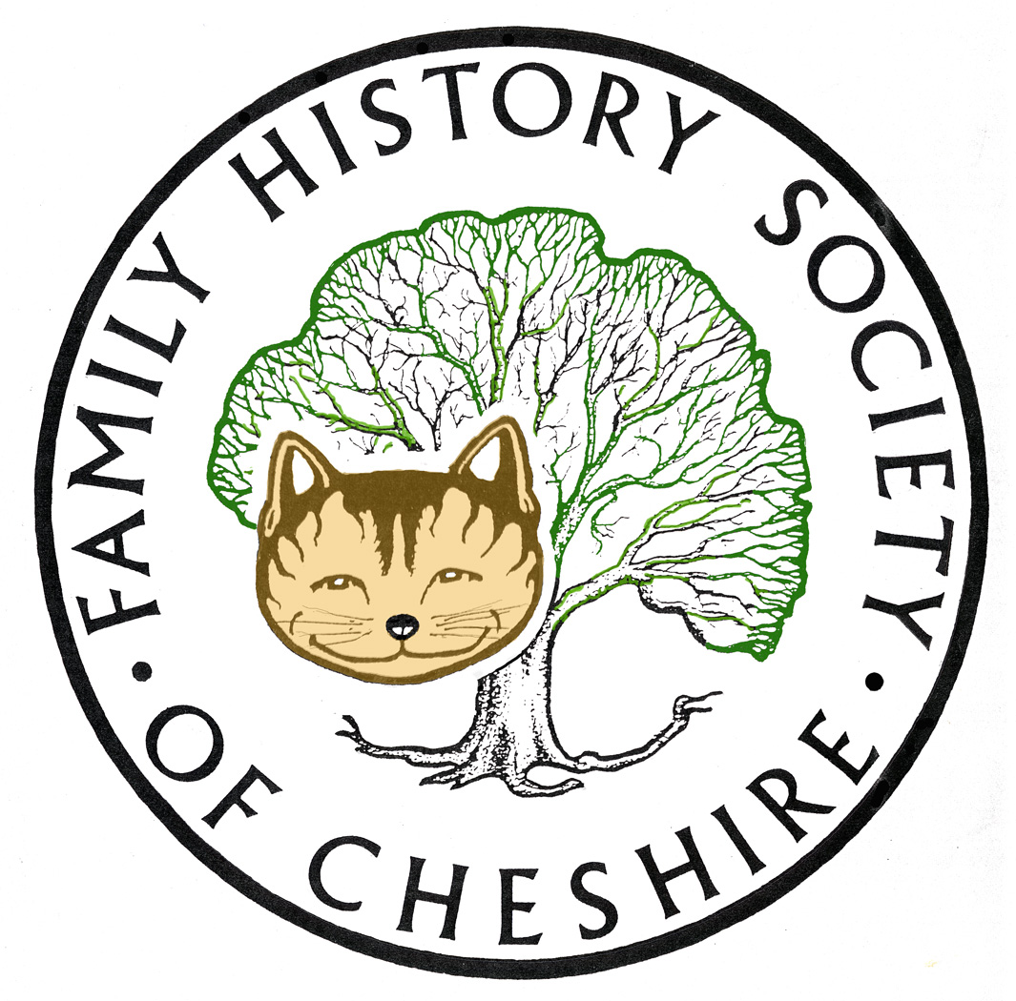
TAMESIDE GROUP NEWSLETTER
November 2015

Don’t Forget to sign up for Lost Cousin’s Newsletter – free and very informative: http://lostcousins.com/ The latest edition contains a very useful article about the best DNA tests and Companies.
THE 1939 REGISTER:
In November Myko Clelland came along to our group to talk about the 1939 Register. I have had some wonderful feedback from this presentation and the general consensus was that it was one of the very best sessions we had ever had and that Myko was knowledgeable, approachable and full of enthusiasm. I hope he can come back again one day. I was particularly interested in learning that his enthusiasm for Family History stemmed from a school project locally to research one of the soldiers on the Stalybridge War Memorial, when he was eleven. It was also lovely to meet his Mum and Dad.
I also want to thank everyone who helped me that evening, since I was in very bad pain. Improving slightly now, but taken me a while to be able to sit at my computer to type this newsletter. Extra volunteers have also helped at our Session in the library this week. I also had to cancel my class.
NEXT MONTH:
We have ordered a potato pie supper from the Astley Arms next door and have been promised a potato pie, red cabbage and beetroot and tiger bread. Sadly we don’t have the same really cheap deal we had with the previous landlady and the cost from them will be £4.50 per head, and we will also provide drinks and mince pies etc. We will have to charge £5 for members and £6.00 for non members. I also have a Family History Quiz courtesy of our Macclesfield Group, which I will customise for Tameside. We also want any suitable raffle prizes.
ANYONE WHO INTENDS TO COME ALONG WILL HAVE TO LET ME KNOW BY MONDAY 30th NOVEMBER. I AM KEEPING A LIST AND IF I DON’T HEAR FROM YOU THERE WILL BE NO SUPPER. LAST YEAR SEVERAL PEOPLE CAME WITHOUT PREBOOKING AND WE VIRTUALLY RAN OUT. THIS YEAR TO KEEP COSTS DOWN I WONT BE ORDERING SEVERAL EXTRA PORTIONS IN CASE.
January Meeting:
Our new society website is nearly ready and I should be able to demonstrate at our January meeting. I will also be demonstrating my favourite family history website: Tribal Pages and also answering iPad questions. By January I hope to complete our programme for 2016.

The FreeBMD Database The FreeBMD Database was last updated on Wed 28 Oct 2015 and currently contains 250,135,010 distinct records (318,896,956 total records). An amazing achievement for the volunteers; a quarter of a billion records.

Historical Victoria BMD Entries available for free:
http://www.bdm.vic.gov.au/home/family+history/search+your+family+history/

VICTORIAN ADVENT CALENDAR:

My little granddaughter really enjoyed Jackie Lawson’s Advent Calendar last year and has asked to play it on my computer through out the year. Her version this year is based upon a Victorian Village and now scrolls and there is an iPad version: at around £2.63/$4.00 it is cheaper than a card and lots more fun, you can also send extra copies as gifts: https://www.jacquielawson.com/advent?source=jl205

FOR ANYONE ON TWITTER: I have started to follow #AncestryHour every Tuesday at 7.00 GMT hosted by @Borders Ancestry. Discussion on all aspects of Family History

Have a look at Family Tree Magazine’s VODCASTS (Video Episodes)

http://www.familytreemagazine.com/info/podcasts

Some of the latest episodes:

November 2015 Episode
In this month's episode, learn how to break down those brick walls in your family tree with fantastic tips and tools from Lisa Louise Cooke and her guests.

October 2015 Episode
This month, learn how to use your time at the courthouse wisely with these 4 tips for finding courthouse records.

September 2015 Episode
This episode is all about getting organized so you can quickly store and secure your genealogical findings and build your portfolio.
Programme for 2015 - 2016:

December 9 – Social - Usual Venue and usual Potato Pie Supper

January 13 – Me about NEW Website iPad Apps and Tribal Pages

February – no meeting

March 9 – Allan Arrowsmith “Denton then and Now”

April 13– tba )

May 11 – tba ) I have some suggestions

June 8 – tba )

July – visit Stockport Hatworks? Or Air Raid Shelters

August 10 Me about Irish Family history Research?

Gay Oliver: gayjoliver@gmail.com 18 November 2015

