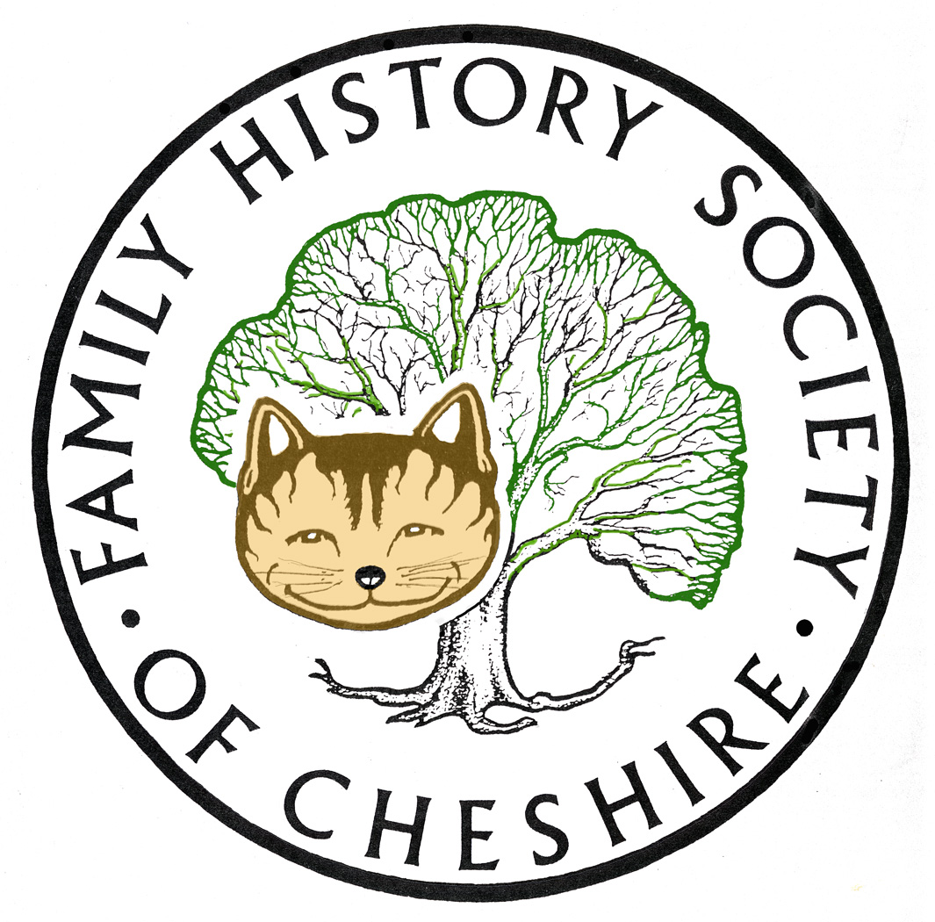
TAMESIDE GROUP NEWSLETTER
November 2012

I have now finished designing rack cards and a roll up banner, which were circulated to members prior to this meeting and have taken on people’s suggestions. I hope to have these available at our meeting in December. I would also love it if people could bring raffle prizes next month. I will also need people to email me with numbers for our potato pie supper. I’m really looking forward to our speaker and it should be an excellent evening.

Cheshire BMD Replaced 12,727 births for Stalybridge to add mothers’ maiden names (1907-1937.
Replaced births 10,722 for Dukinfield to add mothers’ maiden names (1907-1937). Marriages: 26 for Hyde Flowery Field Christian Church 2008-2012.

Find My Past Bright Solid’s partnership with the British Newspaper Library at Collindale to digitally reproduce and index 40 million pages from the newspapers in their collection. Nearly six million pages are available so far via their pay site: www.britishnewspaperarchive.org.uk and are now available at no extra cost to those who have either a FULL or WORLD subscription at Find My Past. They are not available via their library or community subscription.

National Archives: Their latest podcast “Tracing Marriages; Legal Requirements and Actual Practice 1700-1837”, forty minutes long, it debunks the theories of broomstick and handfast marriages, outlines Ecclesiastical requirements and potentially clandestine marriages at the Fleet Prison, and the changes which took place under Lord Hardwicke’s Marriage Act of 1753. www.nationalarchives.gov.uk

War Memorials Online:

The website War Memorials Online brings together for the first time information on the UK’s war memorials held by the leading experts, providing a snapshot of war memorials across the country. It will also provide an unprecedented opportunity for the public to upload images of war memorials and log concerns for the conservation of these important community and historical sources for future generations.
War Memorials Online seeks to create a complete picture of war memorials across the country. But it needs the public to help to ensure there are records for all of the UK’s war memorials and condition reports to ensure at risk memorials can be found before it is too late to save them. Anyone and everyone can get involved in discovering and registering war memorials for future generations.
It is a unique collaboration between War Memorials Trust, IWMs War Memorials Archive (formerly UK National Inventory of War Memorials) English Heritage and members of the public.

Please visit the website
www.warmemorialsonline.org.uk
to find out more.

Irish Lives Remembered: excellent new downloadable Irish Family History Magazine.

National Archives of Ireland: just formally launched, Ireland’s dedicated family history website – www.genealogy.nationalarchives.org.uk the following collections are now free to download with images:

- Census Records for 1901 and 1911
- Tithe Applotment Books for 1823-1837 forerunner to Griffiths Valuation
- Soldiers’ Will 1914-1917

Joining the site in the near future will be:

- Calendars of Wills and Administrations 1858-1922
- Nineteenth century census survivals 1821-1851
- Valuation Office House and Field Books 1848-1860
- Census Search Forms for 1841 and 1851 Censuses

Scotland’s People have extended the coverage of their Wills from 1902-1925.

Programme for 2012 - 2013:

12th December – “My Granddad’s an Oyez Man” John Parsons arrives in the full regalia of the town crier to the Lord of the Manor of Rode Hall or the official regalia of Nantwich Town to give the talk its full potential. Plus a Potato Pie Supper

9th January – Brian Hallsworth ‘From the Old Wives Mouth’ – professional speaker who came last Christmas to talk about ‘In the Bleak Midwinter’.

13th February – Visit to the Local Archives Centre to view the Stamford Estates Archives.

13th March – Barbara Foster ‘The Lady Stamford Reminisces’ National Trust Speaker from Dunham Massey.

10th April – Dorothy Bintley will talk about the Family Search Website including Effective Search Techniques and the use of Batch numbers.

8th May – Dr Susan Deal ‘Cleanliness is Next to Godliness’ the Victorian Obsession with Hygiene.

12th June – David Lambert, member of the Metcalfe Society will be coming along to let us know how belonging to a One Named Study Group has helped with his research.

July – I am suggesting a visit to the working Cotton Mill at Queen Mill in Burnley or Lancashire Record Office.

Any changes or alterations to our programme will be posted on our Society website: fhsc.org.uk click on Groups and then Tameside. Meetings are held in the Old Chapel schoolrooms, Old Road, Dukinfield, on the second Wednesday of each month (except August), starting at 7.00 pm. £1.50 for members and £2.00 for non members, tea and coffee on arrival.

Gay Oliver: gayjoliver@gmail.com 13 November 2012

