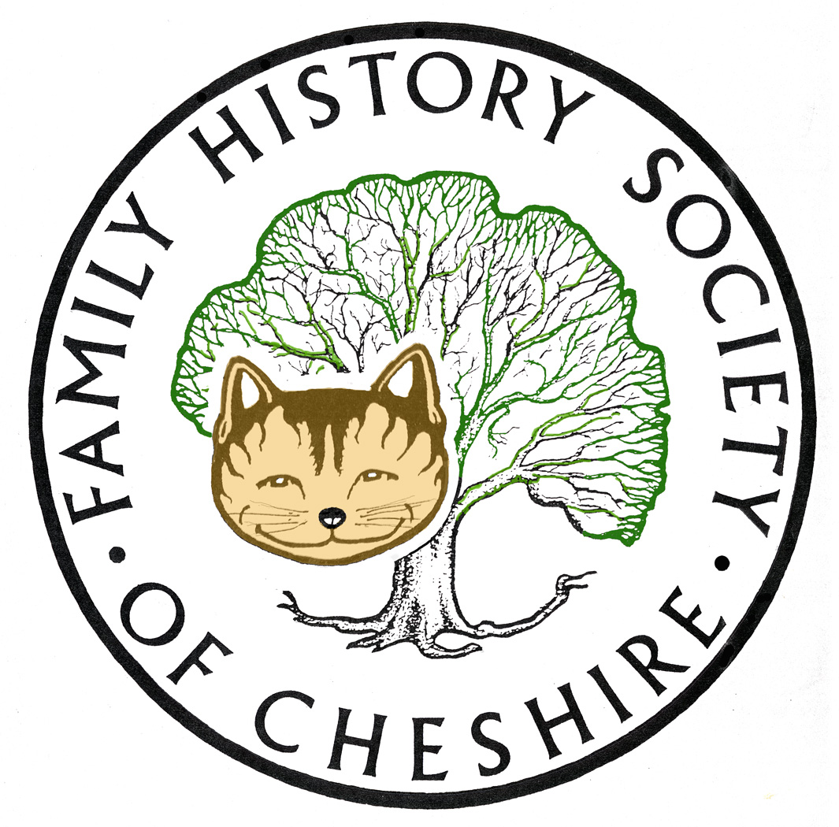
TAMESIDE GROUP NEWSLETTER
MAY 2016

NEED VOLUNTEERS TO TAKE OVER REFRESHMENTS:
Pat will be giving up providing refreshments at our meetings, so we need to find someone else to take on this role. Will talk about it at the next meeting and try to make it as easy as possible for the next volunteers taking over. This will need resolving at our next meeting in June

Find My Past: Virtually all this edition of my newsletter will be about Find My Past starting with this copied from an email received last night:

FINDMYPAST CHALLENGES FAMILY HISTORIANS TO FIND THE ANCESTORS THEY’VE NEVER MET IN THEIR TREE CHALLENGE
· From 23rd May until 30th May 2016, all 1.8 billion records hinted against in Findmypast trees will be completely free
· This includes 570 million UK BMDs, the largest collection available online, over 78 million exclusive parish records you won’t find anywhere else, over 10 million Irish Catholic parish registers and over 116 million United States Marriages
· Findmypast challenges you to find at least one new ancestor through an FMP family tree
· Family historians will be supported with expert insights, help videos, how to guides and a dedicated “tree building” webinar at 4pm on Wednesday 25th May.
London, UK, 20th May, 2016
Is your family history leaving you stumped? Findmypast is here to help with their “Tree Challenge”, a seven day event to encourage people to branch out and discover ancestors they’ve never met. From 09:00 BST, 23rd May until 23:59 BST, 30th May 2016, all hints on Findmypast Family trees and the 1.8 billion records they cover will be completely free to view and explore.
Findmypast is challenging family historians around the world to discover at least one new ancestor by building their family tree on the site, or uploading an existing GedCom file. Researchers will be provided with daily getting started guides, expert insights, useful how to videos and a special webinar hosted by expert genealogist, Debra Chatfield, dedicated to helping you get the most out of your Findmypast family tree.
#TreeChallenge week will have something for everyone, from seasoned experts to complete beginners. Keeping a tree on Findmypast is the first step towards exploring our archive of more than 8 billion records from around the world, more than 1 billion of which aren’t available anywhere else online. That’s over 1 billion family connections you won’t find anywhere else, so explore our collections today to ensure you don’t miss out.
Findmypast trees currently provide matches from birth, baptism, marriage, death, burial and census records across the UK, US, Ireland, and Australia. This includes 570 million UK BMDs, the largest collection available online as well as over 78 million exclusive parish records you won’t find anywhere else. All UK and Irish parish records are hinted against.
Uploading a tree to Findmypast is quick, easy and secure. We will never share your tree or data with anyone else. As you add information, Findmypast does all the hard work for you by sifting through millions of records to instantly identify potential matches. Once potential matches have been made, you can quickly and easily review possible leads before adding the relevant information to your tree.
To encourage you to make the most of this feature, we are running a special tree themed competition. Share any discoveries you make on your tree via social media with the hashtag - #TreeChallenge and you could be in with the chance of winning an expert bundle worth £1000. This includes a 64 GB Ipad mini4, a 3 TB hard drive and a 12 month subscription to ‘Who do you think you are?’ magazine. We will also be giving away a 12 month world sub on our social media channels daily. You can find out more here.
Hinting allows you uncover records for multiple ancestors at once with virtually zero effort. The larger your tree, the more potential matches you’ll be presented with so it’s well worth your while to add as many ancestors as possible.
As we release new records, our hinting system will continue to grow, providing you with even more opportunities to find unknown ancestors.
Find My Past:

I recommend everybody keeps up-to date with their collections by following their blog: https://blog.findmypast.co.uk/

Also here are some links to various webinars and vodcasts given by experts from FindMyPast:

Thursday 12th May Myko Clelland gave a tutorial about Parish Registers. I couldn’t watch at the time because I was on the school run that day, but could watch later using this link:

:http://event.on24.com/wcc/r/1183522/6D78FC8A0CD2D9C8129CF0CDEB9629FE?mode=login&email=gayjoliver@gmail.com

link shortened to: http://bit.ly/20iF1Wj by bitly.com

Another email received this week was about tips and tricks for search Military Ancestors, their collections include 65 Milliion World wide records, covering 250 years of Wilitary History and 33 Million Records from WW1:

link shortened to: http://bit.ly/22j3wo6 by bitly.com This is a You Tube video

There are many more FMP tutorials via this You Tube channel including:

- Census Records
- British Newspapers
- Irish Ancestors
- And lots more

Find My Past Fridays – still releasing thousands of new records each Friday including the following last month:. London Westminster Records, Dorset Parish Registers, Yorkshire Baptism, Marriages and Burials, Irish Electoral Registers, Records from the Boer War and Queensland Births and Marriages. Follow this link to find out more details: https://blog.findmypast.co.uk/fridays/

DON’T FORGET THAT BOTH FINDMYPAST AND ANCESTRY.COM ARE AVAILABLE TO USE FOR FREE AT TAMESDIE LOCAL STUDIES AND ARCHVES LIBRARY and that we have volunteers there helping people on the first and third Tuesday afternoons each month.

UKBMD Project: posting this again from Ian Hartas

Press Release for immediate release from the Local BMD Project - Free Online Tutorials
Over the years I've had the honour to talk at a variety of Family History Society and U3A group meetings on the subject of "BMDs on the Internet", offering an introduction and advice on how to get the best out of the various BMD websites that are part of the Local BMD Project. I've now split my talk up into a set of separate video tutorials which can be accessed, for free, via the UKBMD website. Full details about the contents of these tutorials can be found on the Tutorials page. http://www.ukbmd.org.uk/tutorials

Local Events:

Please have a look at our Local History Forum website: www.tamesidehistoryforum.org.uk

- Details of Centenary events at Albion church
- The latest edition of Lancashire Local History Federation Newlsletter for MAY 2016
- The story of a heritage bridge over the Hollinwood Canal demolished by Oldham Council without consulting the relevant interested bodies.

Can you help the BBC identify the Lost Tommies:
The photographs were taken by a French couple, Louis and Antoinette Thuillier during the First World War and are a fantastic and very natural collection of portraits of Allied soldiers who were billeted in the village when they were away from the trenches. http://www.bbc.co.uk/programmes/articles/3LVxjjZghNQW2LJhx1SsX0t/the-lost-tommies

http://bbc.in/1XoKPOI shortened by bitly.com

Last week Dan Cruickshank was in the Village of Stoneleigh documenting the history of the cottage from medieval times to the Des Res of today available here on iplayer: http://www.bbc.co.uk/iplayer/episode/b07c645b/dan-cruickshank-at-home-with-the-british-1-the-cottage

Shortened to: http://bbc.in/1TlzFLc via bitly.com

Next week he will be talking about the history of terraced houses and I caught a glimpse in the trailer of our local history forum secretary, Christine Clough, showing Dan Cruikshank how to donkey-stone a step. BBC4 9,00pm, Thursday 26th May

Remaining Programme for 2016:

June 8 – Gordon Adshead – “My Stalybridge Adsheads and how a One-Named Study Helped”.

July 13 – Kate Booth an expert on the Military History of WW1 – The Battle of the Somme

August 10 – Possible trip to Stockport Hatworks

September 14 – AGM – plus Me about Irish Ancestors and how it took a DNA test to unlock my grandfather’s illegitimacy and the true name of his father.

October 12 – Frank Rhodes – the History of Belle Vue. He has recently won the Pickstone Prize, a new award that recognises exceptional contribution to championing and helping to preserve the histories and heritage of a community, area or site. For more information: http://www.tamesidehistoryforum.org.uk/frankrhodes.html

November 9 – Possibly Tameside Local History Forum’s study group about their CockBrook Project

December14 – Quiz, Potato Pie supper plus perhaps a speaker still to be arranged.

Gay Oliver: gayjoliver@gmail.com 21 May 2016

