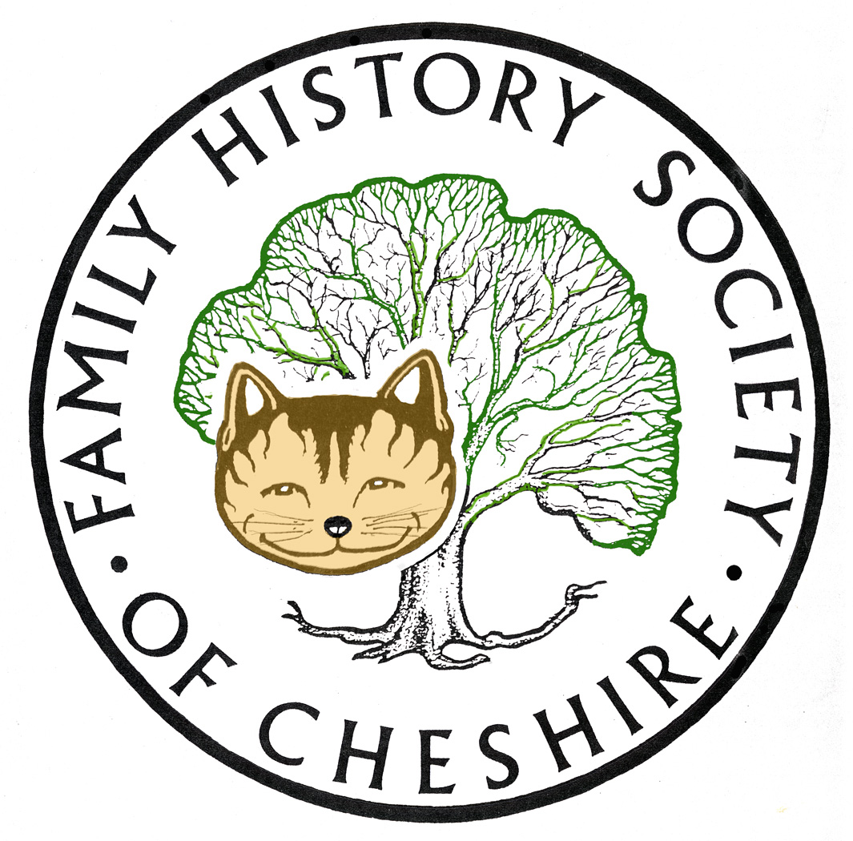
TAMESIDE GROUP NEWSLETTER
May 2014

‘We still need occasional volunteers‘

Our Society Family History Fair held on 10th May at Ellesmere Port. Excellent event and venue and very well organised. Much better than at Northwich and quite straightforward to get to. Thank you to Carl Rogerson for travel to and fro and for sharing our stand as the adminstrator for the Cheshire Rootsweb mailing list. Thank you to Pat Walker, Angela Moore, Bob Douglas and Adrian Brown for taking their turns looking after our stand and giving me time to have a look around. Also to Angela for deputising while I managed to get to hear Dr Nick Barratt’s talk. Excellent speaker and I was enthused again by his views that Family History is serious Social History from the bottom up. Many historians are dismissive of Family History and it was hearing Nick Barratt’s views when he was interviewed about ten years ago, which encouraged me to want to teach others.
Members’ Day 18th October It is Tameside’s turn to host our AGM and Members’ Day this year. I have booked Stalybridge Methodist Church as our venue and so far have six people who will help during the day, but I am going to need another three or four people to help in the kitchen on reception, manning a stand and generally greeting and helping our visitors from all over Cheshire, and many people to contribute some home baked goodies for refreshments. The day will consist of two talks. I am planning to have a talk about the Murder of George Storrs in the morning with perhaps a guided walk in the afternoon. In the afternoon Alan Rose has agreed to talk about Chartism and various Riots and Disturbances in Stalybridge. The business of the AGM usually only takes about half an hour just before lunch. PLEASE HELP ON THE DAY. This is the first time Tameside will be the host.
More details as we get nearer the time.
New Society Website Alan Bennett is hoping to launch towards the end of May and to add features on a monthly basis
British Pathé now published on You Tube:
Film archive British Pathé has released its entire collection to YouTube, making more than 85,000 rare 20th Century videos available to the public.
History enthusiasts are now able to browse more than 3,500 hours of some of the most significant moments of the last century: https://www.youtube.com/user/britishpathe/videos

New 1 month subscription - only £9.95 – British Newspaper Archive
Get unlimited access to nearly Eight million historical newspaper pages with a new 1 month subscription.
http://www.britishnewspaperarchive.co.uk/

Find My Past Have just added nearly two million Shropshire Records and am attaching their press release.

They have also launched all remaining pre1901 census returns from Ireland in conjunction with the National Archives of Ireland:

Dublin, Ireland, 6pm, 28 April, 2014 – The National Archives of Ireland and leading Irish family history website findmypast today announced the release of an extensive series of records that will prove an invaluable resource for anyone tracing Irish ancestry. The records, which include over 600,000 names from pre-1901 Irish census records, are now available to access for free on findmypast and the National Archives website (genealogy.nationalarchives.ie). The launch of the Irish Census records forms part of findmypast’s 100 in100 promise to launch 100 record sets in 100 days.

Ancestry many new additions since out last meeting, so I am copying and pasting from their website:

 | 108427 | 07/05/2014
  NEW Web: UK, WWII Medals Issued to Merchant Seamen, 1939-1945
 | 108720 | 07/05/2014
  NEW Durham Diocese, England, Marriage Bonds & Allegations, 1692-1900 | ...

 | 19613 | 07/05/2014
  NEW Web: UK, Wills of Royal Naval Seamen Index, 1786-1882
 | 132786 | 07/05/2014
  NEW Web: UK, Royal Naval Reserve Service Records Index, 1860-1955 | ...

 | 1028460 | 05/05/2014
  UPDATED Warwickshire, England, Baptisms, Marriages, and Burials, 1535-1812 | ...
 | 277236 | 05/05/2014
  UPDATED Warwickshire, England, Burials, 1813-1910

 | 576830 | 05/05/2014
  UPDATED Warwickshire, England, Marriages and Banns, 1754-1910
 | 510984 | 05/05/2014
  UPDATED Warwickshire, England, Baptisms, 1813-1910

 | 6443 | 01/05/2014
  NEW Durham Diocese, England, Calendar of Marriage Bonds & Allegations, 1594-1815 | ...
 | 159232274 | 29/04/2014
  UPDATED London, England, Electoral Registers, 1832-1965

 | 2665 | 29/04/2014
  NEW West Yorkshire, England, Militia, 1779-1826
 | 336448 | 29/04/2014
  NEW West Yorkshire, England, Prison Records, 1801-1914

 | 32666 | 29/04/2014
  NEW West Yorkshire, England, Police Records, 1833-1914
 | 9093 | 29/04/2014
  NEW West Yorkshire, England, Reformatory School Records, 1856-1914 | ...

 | 45389 | 24/04/2014
  NEW England, Lancashire, Oldham Cemetery Registers, 1797-2004
 | 14252 | 24/04/2014
  NEW England, Norfolk Monumental Inscriptions, 1600-1900's

 | 138680 | 23/04/2014
  NEW England, Norfolk Poor Law Union Records, 1796-1900
 | 322 | 23/04/2014
  NEW England, Yorkshire, Allertonshire, Marriage Bonds and Allegations, 1667-1819 | ...

 | 197227 | 15/04/2014
  NEW Manchester, England, Non-Conformist Births and Baptisms, 1758-1912 | ...
 | 103637 | 15/04/2014
  NEW Manchester, England, Non-Conformist Marriages, 1758-1937

 | 97860 | 15/04/2014
  NEW Manchester, England, Non-Conformist Deaths and Burials, 1758-1987 | ...
 | 544651 | 10/04/2014
  UPDATED Ireland, Select Catholic Birth and Baptism Registers, 1763-1912 | ...

 | 147133 | 10/04/2014
  UPDATED Ireland, Select Catholic Marriage Registers, 1775-1912

Peter Higginbothams new venture – he has launched a companion site to his Workhouse website all about the various types of Children’s homes: http://childrenshomes.org.uk/

Jean Laidlaw, your Journal Editor is still requesting WWI articles for the September edition of the ancestor. She is short of short circa 200 word articles, perhaps about what was happening on the Home Front.
YDNA TEST I now have another exact match this time a man called Don Parks living in Canada – more information soon.
Programme for 2013 - 2014:
June 11 – Kathryn Booth ‘An Inventory of War Memorials in Tameside’
July – I have made preliminary enquiries requesting a visit on one Wednesday in July to the Imperial War Museum for a tour of their “From Street Life to the Trenches” exhibition. Travel should be easy via the Metrolink. I am negotiating extras like lunch in the café first and also a trip up to the Shard Viewing platform. More information soon
In the meantime we need to try and arrange a trip and tour of the New CENTRAL LIBRARY I will also be starting to organize our programme for next year soon, so IDEAS PLEASE!!
Any changes or alterations to our programme will be posted on our Society website: fhsc.org.uk click on Groups and then Tameside. Meetings are held in the Old Chapel schoolrooms, Old Road, Dukinfield, on the second Wednesday of each month (except August), starting at 7.00 pm. £1.50 for members and £2.00 for non members, tea and coffee on arrival.

Our Local Committee met on 30th April mainly to discuss future events, but also the purchase of new equipment. We do have the money but buying a new laptop and projector is going to cost quite a bit. The projector was bought in 2002 (ancient in technology terms) and the netbook in 2007. The netbook still runs on Microsoft XP which is not longer supported from this month. Both these items have started to fail, so we do need replacements. I will let members know what we decide.

Gay Oliver: gayjoliver@gmail.com 13 May 2014

