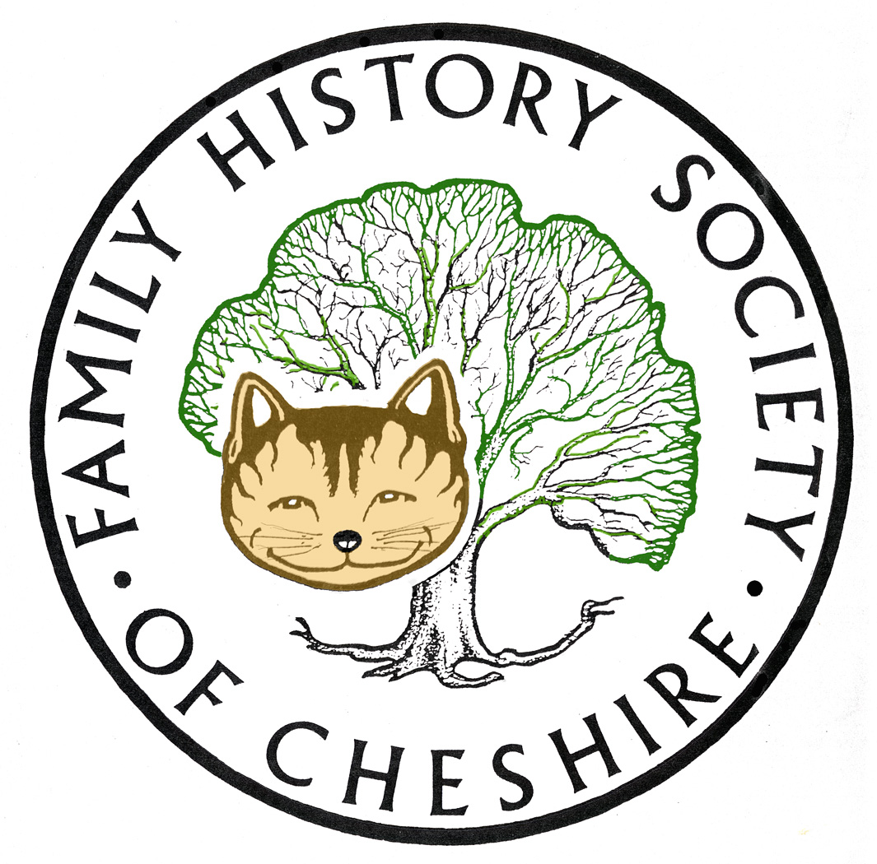
TAMESIDE GROUP NEWSLETTER
May 2013

NOW IS THE BEST TIME TO JOIN OUR SOCIETY: Still time to get an extra couple of months membership if you join now for 12 months cost and five editions of the Cheshire Ancester. Come and look at some sample editions of the Ancestor and ask me for membership forms also please remember to Gift Aid. Societies are beginning to struggle and Gift Aid lets us claim back an extra 20% from the government at no cost to you.

Alice Lock: Very sad to say that Alice retired a week last Friday after 44 years service at our Local Studies Library she will be very much missed, but she is looking forward to some interesting research projects and no more form filling. I’m sure we all wish her well.

FHSC Community Toolbar: You can download it from the menu item on our webpage or from the banner at the bottom of the page. The banner is nice as it shows you how the toolbar looks. I have just finished checking all the links and adding lots of new ones. Once you have it installed any new content will be automatically installed, so no need to re-install. www.fhsc.org.uk
If you have any ideas for further content then let me know via webmaster@fhsc.org.uk

tamesidefamilyhistory.org.uk Over the last few months I have also added lots of new links here and completely checked the content of the webpage. Some very interesting additions here.

Find My Past: have added 650,000 more pages from British newspapers, so there are now 6.5 million online. You'll need a Full or World subscription to view them

Cheshire BMD: Births:
Replaced 12,190 for Audenshaw, registers at Tameside (1929-1974) to add mother's maiden name. I now make it that there are only MMNs to add for Ashton Hospital 1961-1974, Ashton town 1937-1961 and Mossley 1937-1951 left before MMNs are complete in Tameside up until 1974.

Programme for 2013:

8th May – Dr Susan Deal ‘Cleanliness is Next to Godliness’ the Victorian Obsession with Hygiene.

12th June – David Lambert, member of the Metcalfe Society will be coming along to let us know how belonging to a One Named Study Group has helped with his research.

July – I am working on a trip to Lancashire Record Office – more details soon

11th September – AGM followed by me talking about “Barons and Bastards” a study into the slave plantations of the Dukinfield Family in Jamaica and North Carolina including some of their descendants still alive today

9th October – Tony Bostock talking about early sources for Family Historians

13th November - John Creer will talk about DNA and Family History and how it has helped his Creer surname study

11th December – Potato Pie supper with a raffle and quiz and some 5 minute talks by our members

I have also started booking some talks for 2014 including one about the Pendle Witches, another about Easter Customs and perhaps another about the origins of Lancashire Dialect words. I am also trying to book a professional speaker and author about “Barking up the Wrong Tree”. We also propose a visit to The Imperial War Museum North, in time for the centenary of the start of the First World War. I still need ideas for about three more talks.

Any changes or alterations to our programme will be posted on our Society website: fhsc.org.uk click on Groups and then Tameside. Meetings are held in the Old Chapel schoolrooms, Old Road, Dukinfield, on the second Wednesday of each month (except August), starting at 7.00 pm.

Gay Oliver: gayjoliver@gmail.com 8 May 2013

