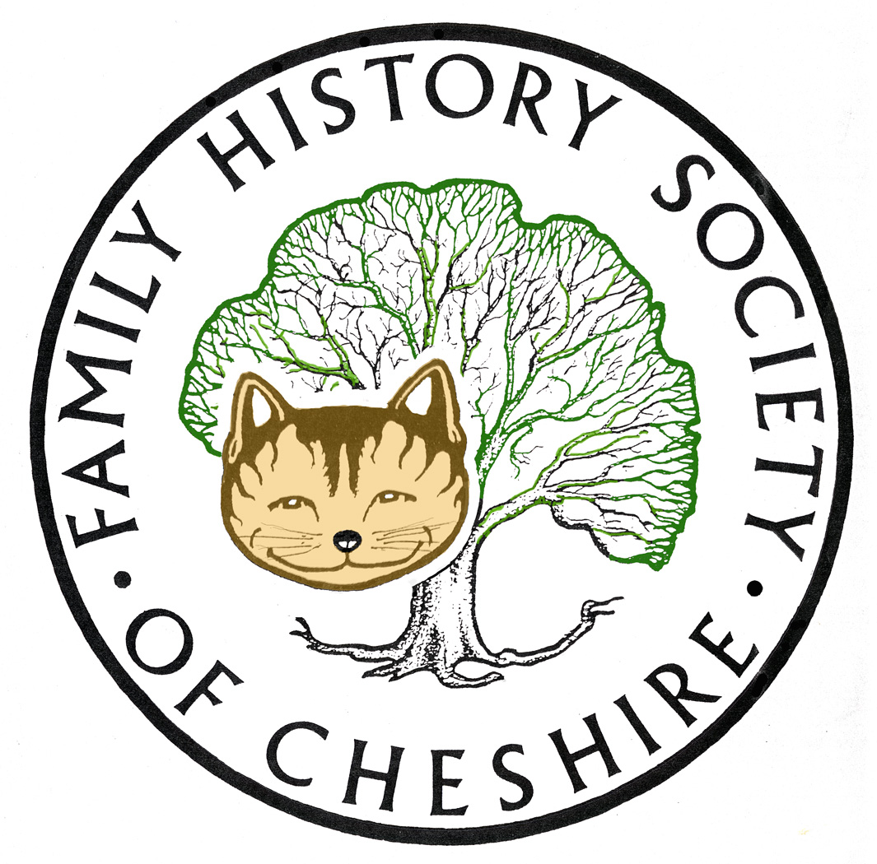
TAMESIDE GROUP NEWSLETTER
March 2013

Ancestry’s Manchester Diocese Collection:
Manchester, England, Births and Baptisms, 1813-1915

Manchester, England, Deaths and Burials, 1813-1985

Manchester, England, Baptisms, Marriages and Burials, 1573-1812 (Cathedral) | ...

Manchester, England, Births and Baptisms, 1813-1901 (Cathedral)

Manchester, England, Marriages and Banns, 1754-1930 (Cathedral)

Manchester, England, Deaths and Burials, 1813-1866 (Cathedral)

Manchester, England, Baptisms, Marriages and Burials, 1541-1812

Manchester, England, Marriages and Banns, 1754-1930

Find My Past: Have just added millions of new parish records to their Westminster collection, bringing the total number of records available to search on findmypast.co.uk to 3 million. The records come from more than 50 Westminster churches for the vast period 1538-1945 and will prove invaluable to anyone tracing their London ancestors. To search these records, select 'Middlesex' from the list of counties on their parish records search page.

Cheshire BMD: Bob Kirk tells me that within the next three months they hope to have completed adding Mothers’ Maiden Names up until 1974.

Keep an eye on my webpage for more up-dates: tamesidefamilyhistory.co.uk/latest.htm and
tamesidefamilyhistory.co.uk/contents.htm and on www.tamesidehistoryforum.org.uk for the latest local history news and talks and exhibitions held locally.

I have completely up-dated my Tameside family history website including checking all links, and research guides and new websites. I also continue to add news from all our local history groups and organizations in Tameside via our local history forum website

Programme for 2013:
10th April – Dorothy Bintley will talk about the Family Search Website including Effective Search Techniques and the use of Batch numbers. Dorothy is an expert on the information gathered by the LDS Church

8th May – Dr Susan Deal ‘Cleanliness is Next to Godliness’ the Victorian Obsession with Hygiene.

12th June – David Lambert, member of the Metcalfe Society will be coming along to let us know how belonging to a One Named Study Group has helped with his research.

July – I am suggesting a visit to the working Cotton Mill at Queen Mill in Burnley or Lancashire Record Office.

I have also already booked one speaker for November 2013 – John Creer will be coming along to talk about DNA and Family History.

Any changes or alterations to our programme will be posted on our Society website: fhsc.org.uk click on Groups and then Tameside. Meetings are held in the Old Chapel schoolrooms, Old Road, Dukinfield, on the second Wednesday of each month (except August), starting at 7.00 pm. £1.50 for members and £2.00 for non members, tea and coffee on arrival.

Gay Oliver: gayjoliver@gmail.com 12 March 2013

