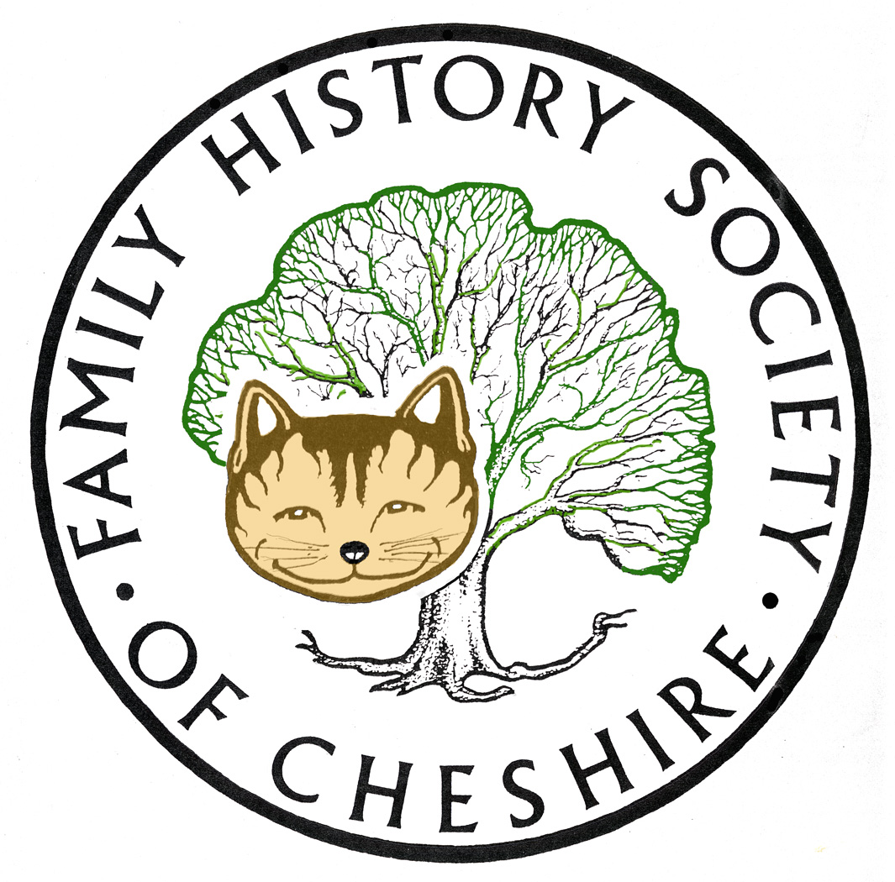
TAMESIDE GROUP NEWSLETTER
June 2016

NEED VOLUNTEERS TO TAKE OVER REFRESHMENTS:
Pat will be giving up providing refreshments at our meetings, so we need to find someone else to take on this role. Will talk about it at the next meeting and try to make it as easy as possible for the next volunteers taking over. This will need resolving at our next meeting in in time for our AGM in September.

Last Month’s meeting – Gordon Adshead

An excellent meeting full of details of the five Adshead Cotton mills in Stalybridge and their involvement with St Paul’s Church. Chance encounters with people whose ancestry was intertwined with his and how registering his surname with the Guild of One Named Studies. He kindly shared some links with us:
http://www.adshead.com/
http://one-name.org/name_profile/adshead/
http://www.theoriginalrecord.com/
For the 1881 Surname Atlas http://www.archersoftware.co.uk/

How to promote your book event Tameside Central Library:

Here are details of an event you may be interested in.

How to promote your book
Friday 24th June, 10.30am – 12noon
Tameside Libraries is proud to welcome Diane M. Hinds from The Entertainment Bureau Ltd. Her talk is aimed at aspiring or small-published writers, who want to know how to promote their book, blog or short story? Come along and learn how to put together a basic campaign that is sure to get you started.
Admission: Free. Please call 0161 342 2029 to reserve your free place
Venue: Tameside Central Library, Old Street, Ashton, OL6 7SG.

Messages Home – Lost Film Archive British Army

North West Film Archive, Manchester Metropolitan University. Sunday 26th June on Channel 4, poster attached.

Heaton Park 1st July:

A free, family friendly, outdoor heritage experience in Heaton Park. Come along and find out what life was like in 1916 here in the UK, and on the fighting front along the Somme. Further information on their website:

http://www.manchester.gov.uk/events/event/3997/experience_field

Tetlow/Tatlow

I have received an email see below:

I don't know if any of your researchers may be interested however I have an old (late 1800s) photograph album with about 39 photos on eBay as of 15 June 2016 and many of the places mentioned on the reverse of the photos are in the Tameside area. The eBay item # is 122015542732. Anyone may contact me at Clovergates@hotmail.com for more information if they wish. Thank you, Bill Tatlow

Ocean Cad: 3D Representations

Sequence of events on 18th March 1819 in Manchester known as the Peterloo Massacre. Created as an exercise to better understand what happened that day. Created using various written accounts and maps found on the internet. Hope you find it informative and useful.

Peterloo: https://vimeo.com/156157535

Also two other videos of Manchester circa 1850

Find My Past Fridays: More details from last Friday copied directly from a regular email I get from Alex Cox.
New records available to search this Findmypast Friday
This week’s Findmypast Friday marks the release of a series of new additions to existing UK and Irish collections as well as some brand new Rate Books from South Australia.
British Newspaper Roundup
Over 2.9 million articles have been our collection of historic British newspapers. This includes the addition of 13 brand new titles and updates to a further 17.
Fascinating new newspapers from all round England, Scotland and Wales have joined the line-up including Kirkintilloch Gazette covering 1898-1938, The Cornish Telegraph covering 1887-1888 and Aberdare Times from 1889. The updates to existing titles in the collection include generous supplements to the Coventry Evening Telegraph (126,975 new articles), Monmouthshire Merlin (180,701 new articles) and Rochdale Observer (163,633 new articles).
Yorkshire West Riding Marriages
Over 49,000 new records from Yorkshire’s West Riding have been added to our collection of Yorkshire Marriages. The amount of information included can vary, but the records usually contain the full names of the bride and groom, their ages, home parishes and the date of their wedding. In some cases the records can also include the names of any witnesses (often family members), the names and occupations of the bride's and groom's parents, the occupation of the groom, the couple's previous marital condition and the name of the officiating minister.
Britain, Knights of the Realm & Commonwealth index
Explore new additions to our Knights of the Realm index to find out if any of your forebears were awarded an order of chivalry. The Knights of the Realm index records the details of over 35,000 individuals who were awarded an order of chivalry by a British monarch. The index was created by Colin J Parry over a 40 year period to determine how many knights were made in each century and, furthermore, who they actually were.
Ireland Dog Licence Registers
Explore more than 343,000 additional records to uncover the age, colour, and breed of your ancestors four legged friend. Now containing over 6.3 million records, the Irish Dog Licences list not only the name, breed, colour and sex of your ancestor’s four legged friend, but also the owner’s address and the date the licence was issued, making them an incredibly valuable census substitute.
Irish Petty Sessions Court Registers 1828-1912
Over 547,000 new records have been added to complete our collection of Irish Petty Sessions Court Registers. Petty Sessions handled the bulk of lesser criminal and civil legal proceedings. They include details of victims, witnesses and the accused, such as address, date in court, details of the offence, details of the verdict and the sentence.
Ireland Poor Law Reports
Search 1,000 new records to learn more about the poor relief efforts in Ireland from the late 1830s to the early 1860s. The Irish Poor Law Act of 1838 created the system of poor law unions in Ireland, which established 130 poor law unions. Under this system, the poor received relief, either from a workhouse or outdoor relief (which included money, goods, clothing, or food) provided for by poor rates assessed under the poor law valuation.
South Australia Rate Books
South Australia Rate books is an index of roughly 4,000 records. The index was transcribed from rate assessments for the coastal district of Beachport in southeast South Australia between 1882 and 1888. Each record includes a transcript and an original image. The amount of information listed varies, but the transcripts usually include your ancestor’s name, assessment year, assessment number, occupier, owner, situation and town. Images may be able to provide additional details, such as property descriptions, rate values, and dates paid.
Don’t forget to regularly check our dedicated Findmypast Friday page to keep up to date with all the latest additions.

Taken from the latest Lost Cousins Newsletter:

6 million more Norfolk parish records at The Genealogist JUST RELEASED

This week 6.23 million records were added to the existing collection, including over a quarter of a million records for Suffolk parishes which border Norfolk. Making 10 Million records in total

The Genealogist also has Tithe Records and Tithe Maps covering 40 counties (initially in black and white the maps are being rescanned in colour), the biggest collection of transcribed parish register entries for Essex (a county very close to my heart), and an amazing collection of Non-Conformist and Non-Parochial records which are held by the National Archives.

The Genealogist is available on one computer at our Mobberley Research Centre

Ancestry add 12 million Gloucestershire records BREAKING NEWS
Ancestry have just added prison records, electoral registers, and Land Tax records for Gloucestershire - a total of more than 12 million records in all. These records are so new that (as I write) they're not included in the Card Catalogue, so to find them you'll probably need to use these links:
Gloucestershire Prison Records, 1728-1914
Gloucestershire Electoral Registers 1832-1974
Gloucestershire Land Tax Records 1713-1833

Ancestry Academy:

Don’t know why, but I have only just discovered Ancestry Academy because I am trying to find out some information about cousins in America:
https://www.ancestry.com/academy/courses/recommended

I am not sure how relevant the information is about UK research, but there are some interesting DNA articles

DON’T FORGET THAT BOTH FINDMYPAST AND ANCESTRY.COM ARE AVAILABLE TO USE FOR FREE AT TAMESIDE LOCAL STUDIES AND ARCHVES LIBRARY and that we have volunteers there helping people on the first and third Tuesday afternoons each month.

Programme 2016/2017

July 13 – Kate Booth an expert on the Military History of WW1 – The Battle of the Somme

August 10 – Possible trip to Stockport Hatworks

September 14 – AGM – plus Me about Irish Ancestors and how it took a DNA test to unlock my grandfather’s illegitimacy and the true name of his father.

October 12 – Frank Rhodes – the History of Belle Vue. He has recently won the Pickstone Prize, a new award that recognises exceptional contribution to championing and helping to preserve the histories and heritage of a community, area or site. For more information: http://www.tamesidehistoryforum.org.uk/frankrhodes.html

November 9 – Possibly Tameside Local History Forum’s study group about their CockBrook Project

December 14 – Quiz, Potato Pie supper plus perhaps a speaker still to be arranged.

January 11 – Eric Millward – The Maiden and the Diplomat – A Georgian Scandal.

Gay Oliver: gayjoliver@gmail.com 20 June 2016

