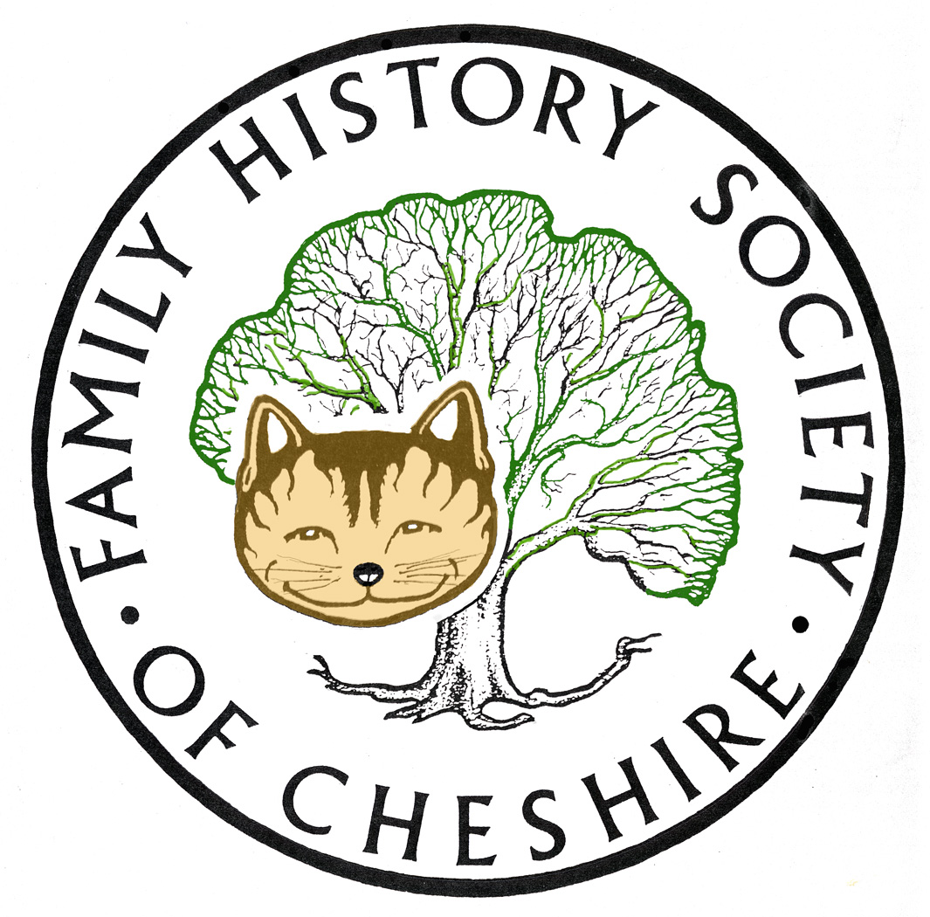
TAMESIDE GROUP NEWSLETTER
June 2013

The latest Podcast at the National Archives looks extremely interesting:nationalarchives.gov.uk

Published date: 31 May 2013
Even the luckiest of family historians will come up against brick walls from time to time. This talk shows that everyone left a paper trail and that it’s almost always possible to find it. It introduces a number of strategies to help you get around the brick walls and dead ends in your research, paying particular attention to getting the most out of online databases and advanced techniques such as ‘family reconstruction’.
Dave Annal worked for The National Archives for ten years, at the Family Records Centre and at Kew. He now runs Lifelines Research where he is frequently called upon by clients to help solve their trickier problems. Dave is the author of a several family history books, notably the second edition of his bestselling beginners’ guide Easy Family History. He is a resident expert on Your Family History magazine and regular speaker on the family history circuit.
Author: Dave Annal Duration: 00:50:48

Ancestry: have added Civil and Mechanical Engineering records and Surrey Parish Registers this month.

FindMyPast:

Over 2.5 million Irish petty session court records added
Posted: 04 June 2013
Over 450,000 parish records added
Posted: 24 May 2013
72,000 World War One Naval records added Posted: 16 May 2013

FMP are also offering 20% off all their subscriptions until 16th June (Father’s Day)

Programme for 2013/2014:

July – I am working on a trip to Lancashire Record Office – Friday 26th July

11th September – AGM followed by me talking about “Barons and Bastards” a study into the slave plantations of the Dukinfield Family in Jamaica and North Carolina including some of their descendants still alive today

9th October – Jill Marshall – Writing Up and Publishing your family history stories

13th November - John Creer will talk about DNA and Family History and how it has helped his Creer surname study

11th December – Potato Pie supper with a raffle and quiz and some 5 minute talks by our members.

8th January – Tony Bostock talking about early sources for Family Historians.

February2014 – Crime and Prison Records in Greater Manchester Gerard Lodge venue The Welcome Inn Ashton-under-Lyne
March 2014 – The Pendle Witches – John Doughty
April 2014 – Easter Customs and Folklore – Brian Hallworth
May 2014 – “Barking up the Wrong Tree” – John Titford
June 2014 – Presentation of an Inventory of World War One War Memorials in Tameside
July possible trip to Imperial War Museum

Any changes or alterations to our programme will be posted on our Society website: fhsc.org.uk click on Groups and then Tameside. Meetings are held in the Old Chapel schoolrooms, Old Road, Dukinfield, on the second Wednesday of each month (except August), starting at 7.00 pm.

Gay Oliver: gayjoliver@gmail.com 12.June 2013

