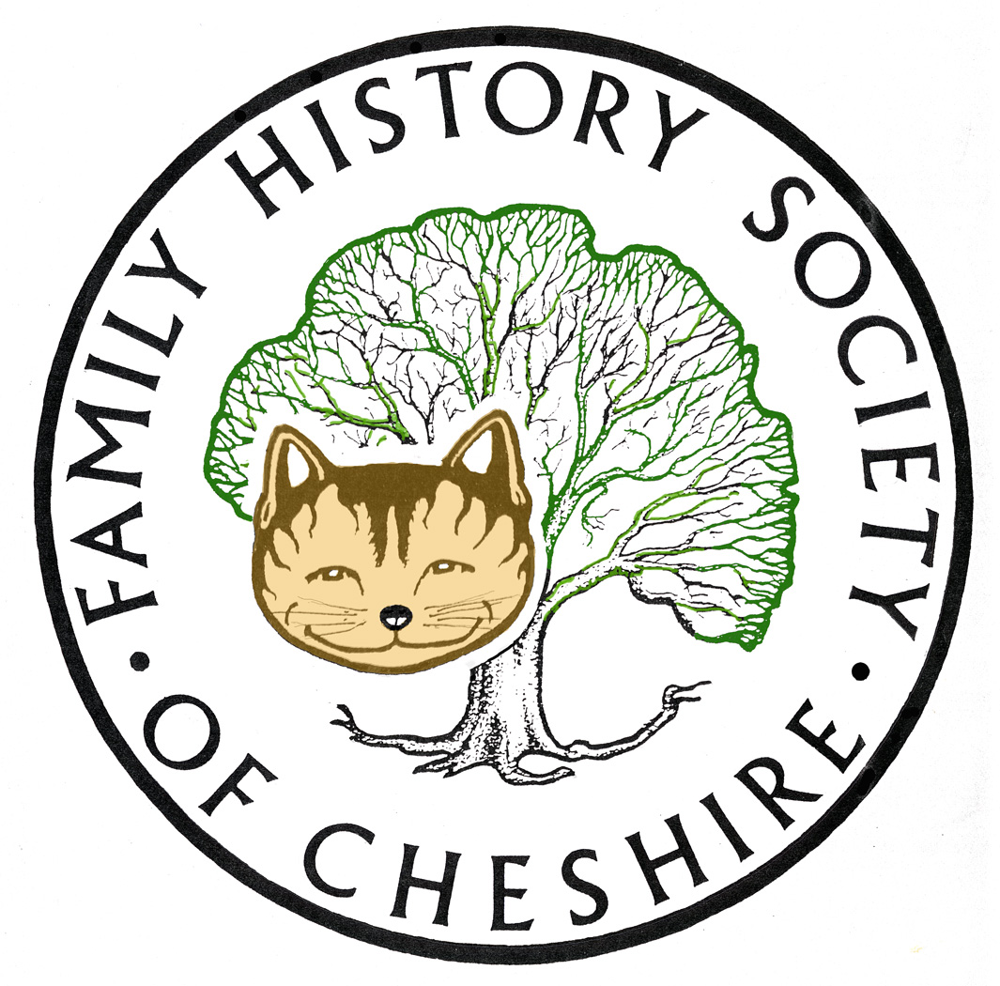
TAMESIDE GROUP NEWSLETTER
July 2016

NEED VOLUNTEERS TO TAKE OVER REFRESHMENTS:
Pat has now given up providing refreshments at our meetings and Pat will be away when its our AGM in September, so we need to find someone else to take on this role. This will need resolving in time for our AGM in September.

150th Anniversary of the birth of Beatrix Potter:

Beatrix Potter had many local links particularly with Gorse Hall Old Chapel, Dukinfield, Hyde Chapel and Stalybridge Unitarian Chapel also with the Gaskell family and Cross Street Chapel Manchester. I am attaching an imformation leaflet and programme for events this weekend.
Ancestry add 7 million Somerset records BREAKING NEWS
Somerset, England, Church of England Baptisms, Marriages, and Burials, 1531-1812
Somerset, England, Church of England Baptisms, 1813-1914
Somerset, England, Marriage Registers, Bonds and Allegations, 1754-1914
Somerset, England, Church of England Burials, 1813-1914
Somerset, England, Church of England Confirmations, 1843-1913
Also included in this release are 47,000 entries from Somerset school registers, and 101,000 entries from gaol registers:
Somerset, England, School Registers, 1860-1914
Somerset, England, Gaol Registers, 1807-1879
Norfolk parish registers now also at Ancestry
Last month The Genealogist added 6 million parish records for Norfolk, taking their collection to 10 million records from the county - this week I learned that Ancestry.co.uk have just added over 8 million Norfolk records, a collection that must inevitably overlap considerably with that at The Genealogist:
Norfolk, England, Church of England Baptism, Marriages, and Burials, 1535-1812
Norfolk, England, Church of England Births and Baptisms, 1813-1915
Norfolk, England, Church of England Marriages and Banns, 1754-1940
Norfolk, England, Church of England Deaths and Burials, 1813-1990
Series 13 of WDYTYA starting soon:

EastEnders actor Danny Dyer, Britain’s Got Talent judge Amanda Holden, star of film and stage Sir Ian McKellen, news presenter Sophie Raworth, The Royle Family actor Ricky Tomlinson, Star Wars and Harry Potter actor Warwick Davis, presenter Liz Bonnin, actor and comedian Greg Davies, actress Sunetra Sarker and popstar Cheryl all discover their past in this year’s series. More information here:

http://www.bbc.co.uk/mediacentre/latestnews/2016/who-do-you-think-you-are

FindMyPast

Register for a free WEBINAR for this Thursday The Society of Genealogist’s Else Churchill will present a free talk about how to break down brick walls pre 1837. Register via the FMP website.

FMP keep adding so many records each Friday its almost impossible to keep up click on the FindMyPast Fridays link in the centre of their webpage to start scrolling - nearly three pages of new releases to scroll through since our last meeting.

DON’T FORGET THAT BOTH FINDMYPAST AND ANCESTRY.COM ARE AVAILABLE TO USE FOR FREE AT TAMESIDE LOCAL STUDIES AND ARCHVES LIBRARY and that we have volunteers there helping people on the first and third Tuesday afternoons each month.

Programme 2016/2017

September 14 – AGM – plus Me about Irish Ancestors and how it took a DNA test to unlock my grandfather’s illegitimacy and the true name of his father.

October 12 – Frank Rhodes – the History of Belle Vue. He has recently won the Pickstone Prize, a new award that recognises exceptional contribution to championing and helping to preserve the histories and heritage of a community, area or site. For more information: http://www.tamesidehistoryforum.org.uk/frankrhodes.html

November 9 – Possibly Tameside Local History Forum’s study group about their CockBrook Project

December 14 – Quiz, Potato Pie supper plus perhaps a speaker still to be arranged.

January 11 – Eric Millward – The Maiden and the Diplomat – A Georgian Scandal.

Gay Oliver: gayjoliver@gmail.com 26 July 2016

