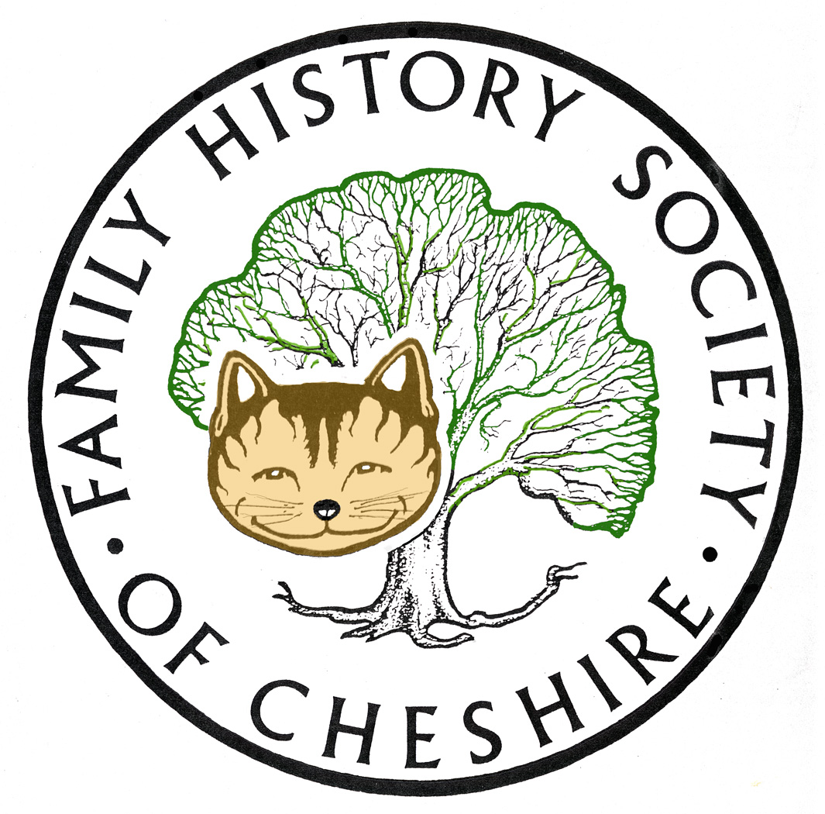
TAMESIDE GROUP NEWSLETTER
July 2014

‘We still need occasional volunteers‘

Members’ Day 18th October Much more news about this at our Group AGM in September
New Society Website has been unavoidibly delayed.

Usually very quiet at this time of year, but I have had difficulty keeping up with all the new and up-dated websites.
Campaign to Open Historic BMD Registers and sample letters: http://anguline.co.uk/ohrn3.html
WDYTYA – moves to Birmingham next year and at a new time of year: http://bit.ly/1q8excT

Series 11 starting sometime in August: Mary Berry, Brian Blessed, Billy Connolly, Brendan O'Carroll, Tamzin Outhwaite, Martin Shaw, Sheridan Smith, Twiggy, Julie Walters, Reggie Yates.
A one hour special will also be broadcast looking back at the most shocking discoveries during the past 100 episodes.
British Newspaper Archive Read all about it - for just £1 trial subscription:
Until Sunday 20th July the discount code SUMMER01 gives you one month's access to more than 8 million pages from historic newspapers.

Please bear in mind that your subscription will renew automatically at the end of the month at the full price of £9.95 unless you change the settings in the My Account section of the website - but it's easy to do and no phone calls are necessary. When you go to My Account click on Personal Details (or choose Edit Details from the dropdown menu) - you'll see "Auto-renew my subscription" right down the bottom.

Find My Past: Nearing the end of their 100 databases in 100 days – see their news page, several American and Irish records added to their worldwide subscription, notable for this month in the UK are the Nonconformist records and nearly half a million RAF and RFC records. They have also purchased Origins.net and Mocava.com. Origins.net is the Society of Genealogists online presence, very good on London and South of England records, very accurate census transcriptions and the National Wills index. The Origins network will continue, but gradually their collections will be added to FindMyPast. Mocava.com is an American search engine, like Google, but only searching through Genealogy collections. Keep an eye on this page for more: http://blog.findmypast.co.uk/

Interestingly a member emailed me today to say that if you already have a subscription to the Times+ digital newspaper, they are offering a one year’s subscription to the UK version of FindMyPast and of course their Times digital archive.

Ancestry: Have just added their Lancashire Collection this month and up-dated lots of Military information visit their new collections website for details: http://www.ancestry.co.uk/cs/reccol/default and click on United Kingdom in the drop down menu

Last month Ancestry added a collection of parish maps which cover England, Wales and Scotland - an added bonus is that the date of the earliest surviving registers is also shown. The parish boundaries are as they were prior to 1832 http://bit.ly/WaDPKd: For maps of English and Welsh parishes in 1851 see FamilySearch: http://maps.familysearch.org/
World War One projects in Tameside: I have been gathering them altogether on a page on the History Forum’s website: www.tamesidehistoryforum/org/uk/ww1.htm I mentioned this at our last meeting, but if anyone wants to add anything to this page please get in touch.
The GenGuide to Bastardy Bonds and Documents (Parish and Poor Law): http://bit.ly/1qxhX4w very useful guide, I must investigate more of this website, don’t know why I haven’t found it before – seems fairly encyclopedic.
How To DNA: http://howtodna.com/ videos and tutorials helping to guide you through various different tests and companies.
Royal College of Nursing http://archives.rcn.org.uk/CalmView/default.aspx catalogue using the familiar Calm View search engine:
History of Nursing: http://lpntornbridge.org/nursing-history/ fairly new and very comprehensive website.
The East End of London: lots to explore here if you have East End Ancestors: http://the-east-end.co.uk/
Anglo Saxon Map of London: see how many modern place names you can spot: http://cdn.londonist.com/wp-content/uploads/2014/01/anglosaxonLONDON.jpg
Latest podcast from The National Archives: Inconvenient people and how to find them: Tales from the Victorian Lunacy panics: http://media.nationalarchives.gov.uk/index.php/inconvenient-people/ The National Archives are also seeking feedback from their enhanced DISCOVERY search catalogue. They have released an expanded version, adding a further 10m record descriptions: bit.ly/1lTcHnF
Significant Dates for Genealogists: useful guide to print off and keep: http://www.epsomandewellhistoryexplorer.org.uk/DatesForGenealogists.html
I am copying this in its entirety from the Lost Cousins Newsletter:
Ireland offers enhanced GRO indexes:
While England & Wales remain resolutely stuck in the 19th century, offering only paper certificates, the BMD registers for Scotland have been online for many years, and earlier this year it became possible to download birth, marriage, and death entries for Northern Ireland.

Recently I learned that the Republic of Ireland is also headed in the same direction. Claire Santry, who writes the Irish Genealogy News blog, summarised it for me as follows:

"A new and improved set of Irish civil registration indexes has been launched on IrishGenealogy, the state-run website best known for its church records microsite. These free indexes differ from those currently available via FamilySearch, Ancestry and findmypast by including births, marriages, and deaths right up to 2013 - as well as a certain amount of additional detail to aid identification.

"The Births Index, which dates from 1864, includes the mother's maiden surname from 1900. Additionally, the actual date of birth is included from 1900 to 1927 and from 1966 to current. The Marriages index, which dates from 1845 for non-Catholic marriages and from 1864 for all marriages, includes the names of both bride and groom for all marriages from 1913, and for some marriages from 1900 to 1912. The Deaths Index, which starts in 1864, includes the age at death from 1924 and the marital status of the deceased from 1966.

"As with the pre-existing online database, the new GRO Indexes cover the entire island up to and including 1921. Thereafter, it includes only those events registered in the Irish Free State/Republic of Ireland.

"Give or take some foibles, the new database has been well-received and it's expected to quickly become the preferred option for family historians searching civil registration records."

But this was the revelation that really caught my eye:

The formal launch of the database in Dublin also delivered some unexpected and very welcome news. Joan Burton, the Minister responsible for the Republic's GRO, announced that the soon-to-be-published Civil Registration (Amendment) Bill 2014 would include plans for Ireland's civil registration registers to make their way online. There's no more on this yet.

Isn't it about time that we heard a similar announcement from England & Wales? It's ironic that having been the first countries in the British Isles to introduce civil registration, they will be the last to put their registers online.

GRO Northern Ireland launched an online certificate ordering website particularly suitable for Family History Purposes – full information here from Chris Paton’s Brish Genealogy Blog: http://bit.ly/1sbouG6

More on using the Northern Irish online BMD platform taken from Chris Paton’s British Genealogy Blog: http://bit.ly/1kSp2sO detailed instructions here.

The website you will need is: http://www.nidirect.gov.uk/family-history basically you have to purchase credits and certificates then only cost £2

Irish petty sessions collection continues to grow
Last June it was reported that the collections of Irish petty sessions records at findmypast had grown to over 12 million, there are now over 21 million records covering the period 1828-1912 - you'll find more details: http://bit.ly/1klSrf7 you will need either a world wide subscription to FindMyPast or to findmypast.ie

Complete list of Church of Ireland of all their surviving parish registers: http://ireland.anglican.org/about/128

Irish 1641 Depositions made fully searchable http://1641.tcd.ie/index.php
Fully searchable digital edition of the 1641 Depositions at Trinity College Dublin Library, comprising transcripts and images of all 8,000 depositions, examinations and associated materials in which Protestant men and women of all classes told of their experiences following the outbreak of the rebellion by the Catholic Irish in October, 1641...
Programme for 2014 - 2015:

September 10 - AGM, Q & A Session and getting to the bottom of the New FindMyPast website.

October 8 – Sandra McLaren, “1066 and all That”

November 12 – Nigel Dunkerley, “Conscientious Objectors and Excepted Occupations”

December 10 – Sid Calderbank, “A Reet Lanky Evening” and Potato Pie Supper

January 14 – Anne McGarry, “The Girls Who Walked Away”

February – visit possibly to Police Museum

March 11 – Peter Park “A Bomb in My Back Garden”

April 8 – Tony Foster, “A Deeper Look at Civil Registration”

May 13 – Peter Higginbotham, “Children in the Workhouse”

June 10 – Me – Poor Law in Tameside

July – Trip possibly to Liverpool Archives and Museums on the Waterfront

Any changes or alterations to our programme will be posted on our Society website: fhsc.org.uk click on Groups and then Tameside. Meetings are held in the Old Chapel schoolrooms, Old Road, Dukinfield, on the second Wednesday of each month (except August), starting at 7.00 pm. £1.50 for members and £2.00 for non members, tea and coffee on arrival.

Our Local Committee met on 30th April mainly to discuss future events, but also the purchase of new equipment. We do have the money but buying a new laptop and projector is going to cost quite a bit. The projector was bought in 2002 (ancient in technology terms) and the netbook in 2007. The netbook still runs on Microsoft XP which is no longer supported. Both these items have started to fail, so we do need replacements. I will let members know what we decide. Have more or less decided on which models to buy and will be able to demonstrate at our AGM in September

Gay Oliver: gayjoliver@gmail.com 13 July 2014

