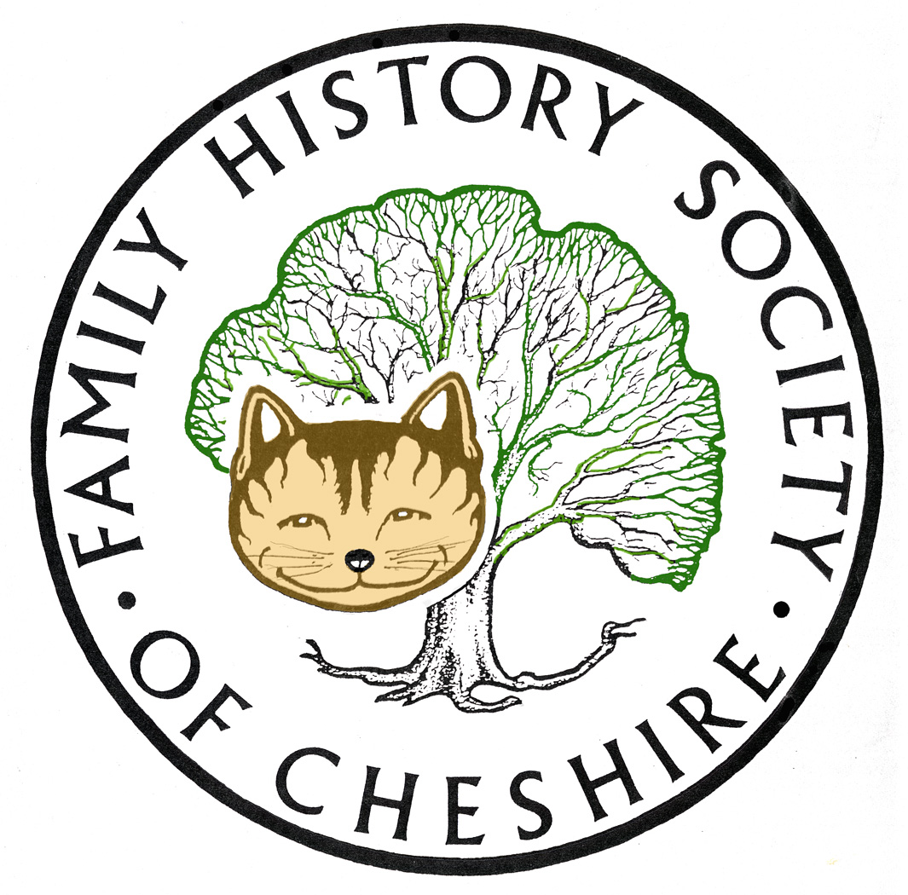
TAMESIDE GROUP NEWSLETTER
July 2012

Library Closures Consultation: I am inviting everyone to give their views on the proposed library closures, currently there are three proposals:

- To only have two main centres of excellence at Hyde and Ashton
- To have five main town libraries at Denton, Droylsden, Ashton, Stalybridge and Hyde and all libraries to have reduced opening hours by five hours. Local Studies to close for two days
- To also include keeping Dukinfield Open, but all libraries to close for two days a week

It is also proposed that Mottram and Hattersley Library would move into the new Tesco Store in Hattersley and Mossley Library to move into George Lawton Hall. This means the closure of Haughton Green, Hurst, Newton and West End libraries. More details and to participate in the Big Conversation: http://www.tameside.gov.uk/tbc

Option 3 is the council’s preferred option, but I am concerned by the two day closure of Local Studies. This may have a huge impact on clients coming to our help desk sessions and my Tuesday morning class, ‘Using Archives for Family History’ which course is supposed to ensure frequent visits to Local Studies. I would be willing to endorse the council's preferred option if Local Studies hours of opening were spread over five days (not four) similar to, but rather longer than) the opening hours of the Central Art Gallery.

I have a set of guidelines set out by the Federation of Family History Societies for anyone wishing to organize a Campaign against Archives closures, can send if you email me.

Cheshire BMD has been updated as follows:
Births:
Replaced 16,276 for Audenshaw, registers at Tameside (1901-1937) to add mother's maiden name.
Deaths:
4,642 for Tameside, registers at Tameside (2007-2012)

Family Search: Old Family Search is no more, so like it or not we will have to learn how to use their new site to best advantage. I have managed to replicate much of the same searches using batch numbers, particularly with the help of Steve Archer’s batch number website: http://www.archersoftware.co.uk/igi/index.htm
It is still possible to search for siblings by using a surname, span of years, and the names of parents. I have found that the search results are very place sensitive, try using exact place name first, but if that doesn’t produce any results, put in the county name instead. There are so many new records appearing on the site all the time that the old site was on the way to becoming obsolete anyway.

Ancestry: Similarly you might be finding it more and more difficult to access their OLD SEARCH screens. I still have the Census and BMD old search screens bookmarked and I also prefer searching individual databases and source, for which I use their card catalogue. But! I have begun to use their NEW SEARCH screens more and more, particularly when using the Archives Library’s Library Edition. The following blog entry describes how you can get the most out of their NEW SEARCH – worth getting used to in case Ancestry also pull the plug on their OLD SEARCH.

The following is taken directly from Peter Calver’s LOST COUSIN’s Newsletter:

Would you allow your family tree to be sold?
Let's suppose you uploaded your family tree to one of the many websites that offers online trees. How would you feel if that website then sold your tree to another website?

Did you realise that when you create an Ancestry family tree, even if it's a private tree, you "grant Ancestry a non-exclusive, transferable, sublicenseable, royalty-free license to host, store, copy, publish, distribute, provide access to and otherwise use such material, including, hosting and access on co-branded services of that material, and to use the data contained in that material as search results and to integrate that data into the Service as Ancestry deems appropriate"?

That comes from Ancestry's - which I suspect a lot of Ancestry users have never even read. The key words are transferable and sublicenseable. You might trust Ancestry with your data (just as, a few years ago, you might have trusted your bank), but can you be absolutely sure that Ancestry won't sublicense your information to someone who you don't trust?

For example, Helen wrote to tell me how annoyed she was to discover her family tree at a site called Mundia. In this case the Mundia site is owned by Ancestry, but it might not have been - Helen had inadvertently given them the rights to license her information to absolutely anyone.

Interestingly, when I read the Mundia Terms and Conditions I noticed that - although they are broadly similar to Ancestry's - the word 'perpetual' has been added. This means that they can go on selling your data even after you've removed it from the site.

Now, before anyone accuses me of waging a vendetta against Ancestry, they aren't alone in this. Another site which claims to be "the world's largest family network" includes in their Service terms the provision "by posting content on the Website, you grant us a royalty-free, worldwide, perpetual and non-exclusive license to host, copy, post and distribute such content." – Peter Calver

Applying for Army Service Records from the Veteran’s Agency in Glasgow

I have just read that it is now taking over a year to process orders, so maybe apply now in case this waiting time increases even further.

FindMyPast have added a further 2 million Welsh parish records, which means there are now nearly 6 million on the site. For full details, including a list of the parishes and other new collections.

http://www.findmypast.co.uk/content/news/2012

They now have a main menu link to view all the records you have viewed since 2010.

Programme for 2012 - 2013:

12th September – AGM and Gay J Oliver ‘New Jerusalem – The Crescent’ An ancestor’s involvement with The Christian Israelites in Ashton-under-Lyne and his later conversion to Islam.

10th October – Joan Irving will talk about the importance of using timelines to understand your ancestor’s Lives.

14th November – Adrian Brown ‘From Royalty to Ruin’ – the story of his ancestor Seth Backhouse.

12th December – Quiz, Social and Potato Pie Supper.

8th January – Brian Hallsworth ‘From the Old Wives Mouth’ – professional speaker who came last Christmas to talk about ‘In the Bleak Midwinter’.

12th February – Visit to the Local Archives Centre to view the Stamford Estates Archives.

13th March – Barbara Foster ‘The Lady Stamford Reminisces’ costumed talk by National Trust Speaker from Dunham Massey.

10th April – Dorothy Bintley will talk about the Family Search Website including Effective Search Techniques and the use of Batch numbers.

8th May – Dr Susan Deal ‘Cleanliness is Next to Godliness’ the Victorian Obsession with Hygiene.

12th June – David Lambert, member of the Metcalfe Society will be coming along to let us know how belonging to a One Named Studdy Group has helped with his research.

July – I am suggesting a visit to the working Cotton Mill at Queen Mill in Burnley or perhaps to Lancashire Record Office.

Any changes or alterations to our programme will be posted on our Society website: fhsc.org.uk click on Groups and then Tameside. Meetings are held in the Old Chapel schoolrooms, Old Road, Dukinfield, on the second Wednesday of each month (except August), starting at 7.00 pm. £1.50 for members and £2.00 for non members, tea and coffee on arrival.

Gay Oliver: gayjoliver@gmail.com 11 July 2012

