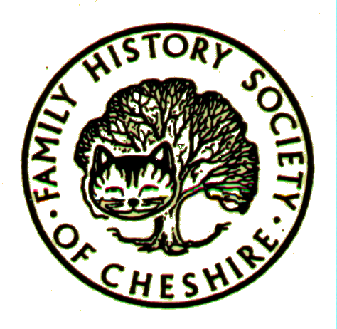
DUKINFIELD GROUP NEWS
July 2007

KEEP YOUR EMPIRE HISTORY ALIVE
On July 2nd, a new series from Channel 4 began. Empire's Children follows six celebrities including Diana Rigg, Lord David Steel and Chris Bisson as they trace their family roots across the world. Channel 4 has developed a website to accompany the series. At http://www.channel4.com/empire you can publish your own family history as it relates to the empire. The aim of the website is to form a personal history of the Empire through the stories of people who experienced it first hand, their relations and descendants.
It is a simple process to upload a story and you can contribute stories from any of the 'empire countries'. You can view example stories already on the site for inspiration. If you think your story is too small, it is still just as important - all stories, be they one chapter or one hundred chapters, are equally important. The more stories that are uploaded, the more complete the history of the empire will be. As a family historian, I am sure you can appreciate the uniqueness and the importance of this resource, and I hope
you will be able to contribute your story.
To accompany the series, Harper Press are publishing Empire's Children: Trace Your Family History Across the World by Anton Gill. You can win your own signed copy of the book if you are one of the ten best Empire Stories submitted to Empire's Children before 1st August, 2007. To enter the competition, register on the 'Empire's Children' website and submit your Empire Story. Then, email empireschildren@channel4.com with a link to your story, your display name and postal address.
Heritage Open Days 6-9 September:
Keep an eye out for Leaflets and Tameside Local History Forum’s website for the most up-to-date information, which will be posted as and when it happens.
Tameside Local and Family History Fair:
This will take place on Saturday 6th October in Jubilee Hall at Dukinfield Town Hall. information will continue to be added to the Forum’s website: www.tamesidehistoryforum.org.uk
Family History Event at Portland Basin Museum 3rd November 2007:
A live “WDYTYA” event being organised by Sue Mitchell who runs the Family History Centre in the Setantii visitor attraction, aimed at anyone who wants to find out more about family history. Sounds as though this will be a really great event for beginners.
CheshireBMD Up-date:
This month 10,635 Ashton Civil Marriages for Tameside (1991-2006) have been added
PROGRAMME 2007:
- September 12th - AGM
- October 9th – Craig Thornber “Death and Disease in the 19th Century
- November 14th – Dr Mike Powell – Manchester Cathedral Registers
Meetings are held at the Old Chapel schoolroom, Old Road, Dukinfield, on the second Wednesday of each month (except August), starting at 7.00 pm. Tea/coffee, and biscuits are provided, and a £1 donation per person is requested. If you have any news or queries to put into the newsletter, please contact Gay Oliver by e-mail at: gayjoliver@aol.com

