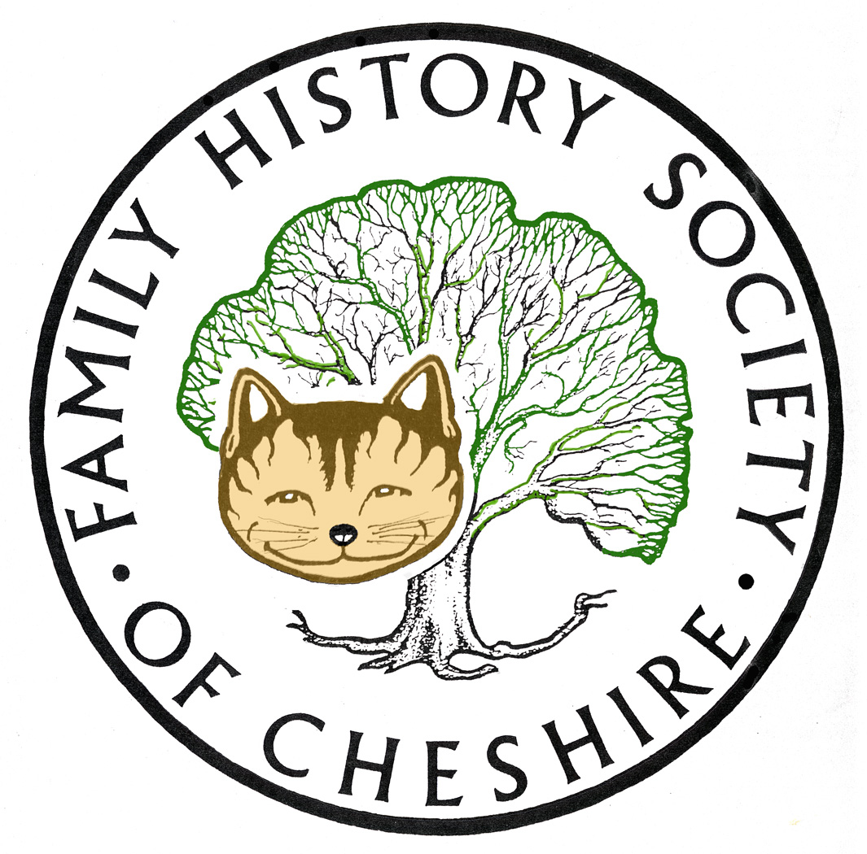
TAMESIDE GROUP NEWSLETTER
January 2017

SOME THANKS TO REFRESHMENTS VOLUNTEERS:

So pleased that Pam Evans, Jenny Lever and Anita Wozniak are now helping with refreshments with a couple of other volunteers in reserve. I am extremely grateful and so are all our visitors.

FIND MY PAST ANNOUNCEMENT: London, UK. 12th January, 2016
Leading family history website, Findmypast, has just announced that their entire collection of birth, marriage, death and census records will be completely free to search from 08:00 GMT Thursday 12th to 07:59 GMT Sunday 15th January 2017.
By providing four days of free access to these essential records, Findmypast hopes to encourage fledgling genealogists to start building their family tree and discover at least one new ancestor through their records. Researchers will also be provided with daily getting started guides, expert insights and useful how-to blogs over the course of the free weekend.
The free access will cover all 1.9 billion records currently matched against Findmypast’s family trees, including;
Including;
· Over 583 million British BMDs
· Over 338 million US & Canadian BMDS
· Over 34 million Irish BMDS
· Over 26 million Australian & New Zealand BMDS
· Over 257 million British Census records
· Over 703 million US & Canadian Census records
· Over 9 million Irish Census records
· Over 487,000 Australian & New Zealand Census records
Findmypast trees currently provide matches from birth, baptism, marriage, death, burial and census records across the UK, US, Ireland, and Australia. This includes Findmypast’s vast collections of more than 140 million United States marriages and over 10 million Irish Catholic baptisms, marriages and burials. Findmypast’s entire collection of 583 million UK BMDs - the largest available online - will also be free to explore, including over 80 million exclusive parish records you won’t find anywhere else. All UK and Irish parish records are hinted against.
Hinting allows you uncover records for multiple ancestors at once with virtually zero effort. The larger your tree, the more potential matches you’ll be presented with so it’s well worth your while to add as many ancestors as possible.
LOOKING FOR DESCENDANTS OF JOHN OUSEY
With regard to the above named our Audenshaw Local History Society is looking to place a marble which we rescued from Red Hall church some number of years ago prior to demolition. It would be the icing on the cake if we can have a descendant/family member to unveil the monument. Would it be possible for an appeal go out on the Forums Facebook/website for an appeal for anyone with any information. We are currently looking towards the Monday 27th March for the ceremony the venue is Ryecroft Hall Audenshaw for installation.
John Ousey was an elder of the original old Red Hall chapel which is now beneath the waters of the reservoirs in Audenshaw. He departed this life 10th November 1873 in the 75th year of his age. He was 75 years of age so born in 1799. He was what we would call today registrar for Audenshaw, Littlemoss Droylsden, and lived at Jasamine Cottage, which has now sadly been demolished.
His remains (together with other family members) were removed from the grounds in the Old Hall Chapel then Re-interned in the grounds of the new Red Hall Chapel on Audenshaw road Audenshaw in July 1877. The grave is still there today now in the small cemetery of the new building of Trinity Church.
Bob Kirk might remember that he was the Registrar at the beginning of Civil Registration and could often spell names in three separate ways in the same entry.
I did know an Ousey descendant many years ago who lived in Australia, but lost touch with her about 15 years ago.
WDYTYA WILL RESUME LATER THIS MONTH
Who Do You Think You Are? resumes on BBC One towards the end of January

Britain’s Got Talent judge Amanda Holden, star of film and stage Sir Ian McKellen, news presenter Sophie Raworth, Star Wars and Harry Potter actor Warwick Davis, actor and comedian Greg Davies and actress Sunetra Sarker all discover their past in this year’s series. More information here:
http://www.bbc.co.uk/mediacentre/latestnews/2016/who-do-you-think-you-are

ANCESTRY:

How to find out their latest additions – use this page:
http://www.ancestry.co.uk/cs/recent-collections Just enter the country in the top box.

I have recently tried to trace some of my Belgian Family who emigrated to Canada and the US after the war. Two of my mother’s cousins married Americans, one in Niagara Falls and another to Seattle. I have found when they left Bruxelles to sail via Rotterdam to New York, one family went to Montreal initially and then crossed over to the USA and I found details fo their crossing and also the address they were going to in the USA. Have found various telephone directories showing where they lived and their occupations over a period of time and lastly their Social Security Death Indexes. I still have a cousin over there that I am in contact with and found her on Facebook.

Have also found another American website which appears to give current addresses of people in the US via Dick Eastman’s BLOG

Family Tree Website Reveals Personal Address, Family Information
Dick Eastman · January 11, 2017 · Current Affairs, Online Sites · 24 Comments
Snopes.com reported on a family tree website that is causing a lot of alarm to the general public as it reveals a lot of personal information.
FamilyTreeNow.com claims to be a family history and genealogy web site but seems to be primarily a site that publishes public information about individuals. In fact, there are a number of other web sites that do the same (Spokeo, Intellius, BeenVerified.com and perhaps a dozen or so others) for a fee but FamilyTreeNow.com provides basic information free of charge.
The website allows anyone to enter a person’s name and then displays whatever personal information the web site knows about people of that name. In many cases, results show personal information along with the names, ages and addresses of people they are related to.
I have found a long lost Aunt and Uncle both in their 90s living in SEATTLE, I wasn’t even sure they were still alive.

VIRTUALLY BREAKING NEWS: GRO UP-DATE

The General Register Office announced today (3/Nov/2016) that their historic births and deaths indexes are now searchable online via the GRO's own website.

Although you can no longer apply for cheaper PDF copies of Certificates the enhanced indexes are still free to search.

Their announcement stated: "GRO Online Historic Indexes Following successful development and testing, the GRO online historic birth and death indexes are accessible via our website from today, 3 November. The indexes have been created using GRO records which have already been digitised, and cover birth records more than 100 years old, and death records up to 1957 (the latest digitised year we hold). The online indexes, will provide a customer enhancement, making the indexes more readily available for searching than the microfiche we currently make available via the 7 public libraries / records offices across England and Wales. This service will be in addition to, rather than replacing the facility to search the indexes at the 7 sites. The full set of indexes will still be held and updated at these sites. The online index also provides enhancements, to that on the microfiche, where possible showing mother’s maiden name for births prior to 1911, and age at death for those records prior to 1865. There is also the facility to purchase a certificate. The index is accessible free of charge via the GOV.UK website which links to our online ordering site."

You will need to register first at: https://www.gro.gov.uk/gro/content/certificates/Login.asp and from there it is easy to search and very quick to show results.

I would still use Cheshire BMD for local Tameside records because these are complete and do give the above extra details, but if your ancestors came from anywhere else, its well worth giving this new resource a try, particularly if you had a fairly common name and don’t know which certificate to order, the extra information may help to pinpoint it.

NEW SOCIETY WEBSITE NOW LAUNCHED

It had a soft launch to officers of the Society a couple of days before Christmas, where we tested and corrected minor faults etc, but was officially launched last weekend www.fhsc.org.uk
This website has much more functionality than our old site and we plan to add more as we go through 2017.

There are different levels of access to the site:

PUBLIC, REGISTERED WEBSITE MEMBER, PAID UP MEMBER, GROUP COMMITTEE MEMBERS and OVERALL OFFICERS OF THE SOCIETY.

PUBLIC: You will be allowed to browse the shop (when it launches) and attend meetings and research centres at visitor rates.

REGISTERED WEBSITE MEMBER (FREE): as above plus being able to buy from the shop, follow any of the groups, sign up for group newsletters and add their Cheshire surname interests.

PAID UP MEMBERS: to receive quarterly copies of our Magazine, The Cheshire Ancestor either printed or electronic. It’s cheaper to opt for our electronic version. There are also electronic exchange versions of Magazines from other Societies. You will be able to add all your surnames world-wide, access research resources. Mostly reduced rates to attend meetings and research centres.

GROUP COMMITTEE MEMBERS: will be able to amend any of their groups webpages following instructions in FAQ.

OFFICERS OF THE SOCIETY: Access to pages to streamline the running of the Society and our complete archive dating back to 1969.

I has not been possible to carry forward members’ passwords so you will have to reset your password the first time you visit.
Click on Login in the top green menu and then use the Forgot Your password? link. On the next screen which opens you should enter your email address and then click on submit. Be aware that the Submit button only works after a number of seconds (this is to protect us from attacks by robots).
Now go to your email inbox and look for an email from us. If you cant find it then check in your junk/spam folder. If you dont receive it then please contact the Web Administrator via Contact Us.
Also contact us if your email address is rejected as it means our records need updating.
If you do get the email then click on the link which will take you back directly to our website to reset your password.
Please make this a strong password: at least 8 characters long with a combination of upper and lower case letters, numbers and symbols
Once you have logged in you can look at the data we hold about you that may need changing. You will find it in the My Membership menu under the Member Admin options.
Good Luck! and Welcome to our New Website. This is not a static website and we will continue to add to it and increase facilties throughout 2017.

Have a good wander around the website and explore some of the menus which open up as you hover over others, add some of your surnames etc – there is a lot here.
NORTH CHESHIRE FHS
Sadly folded just before Christmas and approached our society for help to merge with our Society. Members of their Hazel Grove group will merge with our Bramhall Group and the Sale Branch wants to continue as a group as one of our Family History Society of Cheshire Groups.
The new Sale group of the FHSC has now been officially formed, has a committee and has held its first meeting.
It does not yet have a set of pages on the web-site but this will be resolved over the next couple of days.

DON’T FORGET THAT BOTH FINDMYPAST AND ANCESTRY.COM ARE AVAILABLE TO USE FOR FREE AT TAMESIDE LOCAL STUDIES AND ARCHVES LIBRARY and that we have volunteers there helping people on the first and third Tuesday afternoons each month.

Programme 2017

February – no meeting due to Chapel Pantomime

March 8 – TO BE CONFIRMED

April 12 – Denise Bates – “Women and Children down the Mines”

May 10 - Rita Greenwood “Holy or Unholy Matrimony”

June 14 – maybe a trip

I have a couple of ideas waiting to be confirmed to fill the gaps and will let people know as I confirm dates.

Gay Oliver: gayjoliver@gmail.com 13 January 2017

