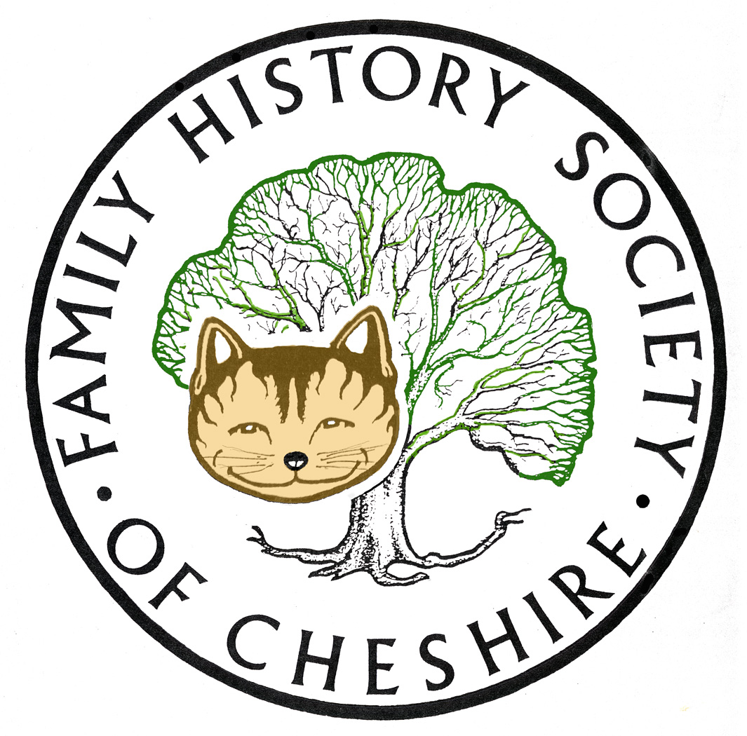
TAMESIDE GROUP NEWSLETTER
14 February 2014

Sadly the only thing that arrived on my doormat this morning was my credit card bill. Nothing with a stamp and hand written address

Cancellation of February Meeting: this was cancelled at the last minute due to storm conditions and transport disruption. After a mad rush of trying to contact as many members as possible, sending out last minute emails and announcing on Facebook, Twitter and our Website we managed to prevent all but three people turning out, which was pretty good. Can I suggest that in future, if there is any doubt due to weather etc, please check our website for any annuncements on the main homepage: fhcs.org.uk There is no need to login for this.
Family History Society of Cheshire Family History Fair: New venue new date. This year on Saturday May 10th at Ellesmere Port Civic Hall. We will have three speakers including Dr Nick Barratt of WDYTYA fame – poster attached.
Jean Laidlaw, your Journal Editor is preparing a special edition of Cheshire Ancestor for next September. She has asked the Committee to pass the word down-the-line (there’s a bit of WW1 jargon!). Please see her article in the latest edition of the Ancestor when it lands on your doorstep.
Society Website: Our Society website is now five years old and needs more functionality, so Alan Bennett, our webmaster, is designing a complete overhaul of our site. If anyone has any suggestions please get in touch with me.
RootsTech: RootsTech run the largest Family History and Technology conference in the USA, based in Salt Lake City it ran from 5-8 February. For a limited time only they have released a representative sample of seventeen of the talks in a series of videos on their website and many handouts which were issued during the event. Scroll down to the bottom of the page: https://rootstech.org/
National Archives: have revealed Conscription Appeals held at the Middlesex Apeals Tribunal you can read more here: http://blog.nationalarchives.gov.uk/blog/commemorating-conscription/
Find My Past: have now released 2.5 million records held at the British Library for families in British India these include:
These 2.5 million records include:
- Baptisms, Marriages & Burials (Catholic, Anglican & Civil registers)
- Army officers’ marriage notifications
- Records for other locations administered by the India office (Aden, Burma, Kuwait, St Helena)
- Civil service records
- Pension registers
- Probate records & wills
FMP have also reduced their subscriptions:
British Full Subscriptions: one month £9.95 – full annual subscription £99.50
World subscription: one months £12.95 – full annual subscription £129.50

Ashton Grammar School World War One Memorial:
I have been researching the names of the students and a teacher listed on the Memorial. This was for a proposed Heritage Lottery Bid to have the memorial renovated and for Ashton Sixth form to turn their lives into a drama. Several partners were involved in the bid and we are pleased to announce that we have won funding. Eventually they also hope to turn the drama into a film to show at Portland Basin. I handed over details of my research yesterday.
By next month I should have a list of WW1 projects taking place in Tameside
Useful Site for peer comparisons and reviews of Genealogy and Family History Software:
http://www.gensoftreviews.com/ a site which keeps up-dating as people recommend software.
Can anyone help Frances Switala?
‘Sorry to ask as I am no longer a member having preciously joined the Bramhall group. member number 8637UN.
I have a commemorative plaque for a P.N.G. Robert Woodhouse of the Prince Of Wales Lodge Mossley, M.U. He died 5th December c 1888 aged 88, interred at St George's Chapel.
He is described as a 'highly respected brother'
Does this sound like a masonic lodge to you? Is there a St George's Chapel in Mossley? Any idea what the title P.N.G. represents? I am not sure that this is Mossley in Tameside but welcome any comments as I want to return it to his family if I can find them. Frances.’
Please get in touch with me if you have any ideas. GAY
My Brother’s YDNA Sample has arrived at FTDNA. Our Family Surname CULLEN. There is also a CULLEN DNA project running in Ireland, so I am waiting to find out which historical CULLEN DNA Clan we belong to. Fingers crossed I find out something positive about our Irish roots.

Programme for 2013 - 2014:

March 12 – John Doughty ‘Lancashire Witches’ and particularly the Pendle Witches
April 9 – Brian Hallworth ‘Easter folk” will take a look at the origins, customs and traditions of Easter, from pre Christian times to today.
May 14 – John Titford ‘Barking up the Wrong Tree’ author of several family history books, will be explaining how easy it can be to 'bark up the wrong tree' using examples.
June 11 – Kathryn Booth ‘An Inventory of War Memorials in Tameside’
July Trip to the Imperial War Museum North
Any changes or alterations to our programme will be posted on our Society website: fhsc.org.uk click on Groups and then Tameside. Meetings are held in the Old Chapel schoolrooms, Old Road, Dukinfield, on the second Wednesday of each month (except August), starting at 7.00 pm. £1.50 for members and £2.00 for non members, tea and coffee on arrival.

Gay Oliver: gayjoliver@gmail.com 14 February 2014

