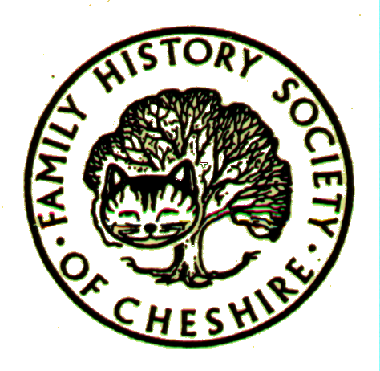
DUKINFIELD GROUP NEWS
December 2007
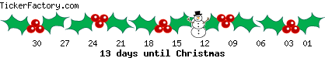

**Thanks to everyone who helped this year – particularly Doris, Pat, Anita and Lilian**

Cheshire BMD:

Just added on 30th November 18,804 death entries for Stalybridge 1897-1937.
FUTURE EVENTS:
- FHSC – Northwich Family History Fair 23RD February 2008.
- Stockport Family History Fair Sunday 6th April 2008 at Stockport Town Hall
TOMBOLA:
Please can everyone think of saving anything suitable for our tombola at Northwich. Maybe anything unused from Christmas? If you can bring them to our January meeting and I will take them to Anderton in time for the fair on 23rd of February
FFHS JOINS FORCES WITH FINDMYPAST.COM:
The first collaboration is the migration of 10 million records from the National Burial index now available at FindMyPast. Click on the BMD Tab.

CHESHIRE LOOK-UP EXCHANGE:

I am just reminding people again about this relatively new website. For anyone who doesn't know what it's all about, it is an ever-growing list of volunteers who have resources in their possession and who are willing to do "look-ups". Plus there are numerous links to on-line searchable resources, mostly for Cheshire. Please think of offering to join yourself to offer local look ups. There are so many wonderfully helpful people out there. Why not take a look? Please take time to read the instruction if this is your first visit. You will find the Cheshire Look Up page at:

http://mysite.orange.co.uk/cheshirelookup

BRITISH HISTORY ON-LINE:

I have been highly recommending this website for a couple of years now. It is a very important resource for historians and is entirely free and very easy to search. It includes full access to the Victorian County Histories reference books, Parliamentary and Ecclesiastical papers. The best bit though is their much improved series of free, searchable maps based on the first OS series. I used to use old-maps.co.uk, but was very sad when this became a very expensive proposition earlier this year, so I am delighted to find an alternative which is nearly as good:

http://www.british-history.ac.uk/

MYFAMILY.COM:

Part of Ancestry.com and much as I hate to admit it, this does look rather good. A sort of family scrapbook, social networking, upload your photos and videos, create discussion groups. You can customise the look of your site and even use it as a blog. I am still extremely wary about up-loading actual family trees and so many people are still adding living people to their information on-line without seeking permission. It is extremely impolite and incautious to publish anything about living people on the web or in any other form of publication. Take care as well when creating profiles on-line – no dates of birth, telephone numbers, mother’s maiden names etc., PROTECT YOURS AND OTHER PEOPLE’S IDENTITIES.

My family.com plan to introduce charges for anything more than their basic site next year, but since the lowest charge is $2.50 per month perhaps it won’t be exhorbitantly expensive. It is also a relatively cheap way of having a presence on the web without having web creation skills and paying for a domain name and web space. So far I have created a very basic site to see how it works and have subscribed to their newsletter to watch developments.

Other websites are also offering similar personal space, for instance FindMyPast and FamilyRelatives.com. This is all part of the internet getting more interactive and based on the success of sites like YouTube, MySpace and Facebook.

Another way forward in the realms of interactivity is based on WIKI technology as in WIKIPEDIA, with its user generated content. Two major websites have recently added WIKI content to their sites:

www.familysearchwiki.org and http://yourarchives.nationalarchives.gov.uk

Both are still in BETA testing, but have a look and see what you think so far.

DUBLIN CENSUS:

At last the first part of the surviving Irish census has gone on-line. This is the 1911 Census for Dublin only at present, but the rest of Ireland will eventually go on-line:

http://www.census.nationalarchives.ie/
NEXT MONTH:

Alan Arrowsmith from Denton Historical society is coming to talk about the history of Denton and its importance as a centre for the hatting industry. Alan is a very experienced speaker and researcher. It should be a pleasant change to hear about a different part of Tameside and a different but equally important trade locally.
PROGRAMME 2007/2008
- 9 January 2008 - Alan Arrowsmith - "Denton and Hatting"
- 13 February 2008 - "Maps Workshop at Tameside Local Studies Library"
- 12 March 2008 - Alan Hayhurst - "Lady Killers"
- 9 April 2008 - Peter Park - "Parish Registers"
- 14 May 2008 - "Open Forum"
- 11 June 2008 - "Afternoon visit for a Concert and Tour of Chetham's Library"
- 9 July 2008 - Jan Craig - "Palaeography"
www.fhsc.org.uk/fhsc/dukinfield.htm

Meetings are held in the Old Chapel schoolrooms, Old Road, Dukinfield, on the second Wednesday of each month (except August), starting at 7.00 pm. Tea/coffee and biscuits are provided, and a £1 donation is requested. Please email me with any items for the newsletter: gayjoliver@aol.com

