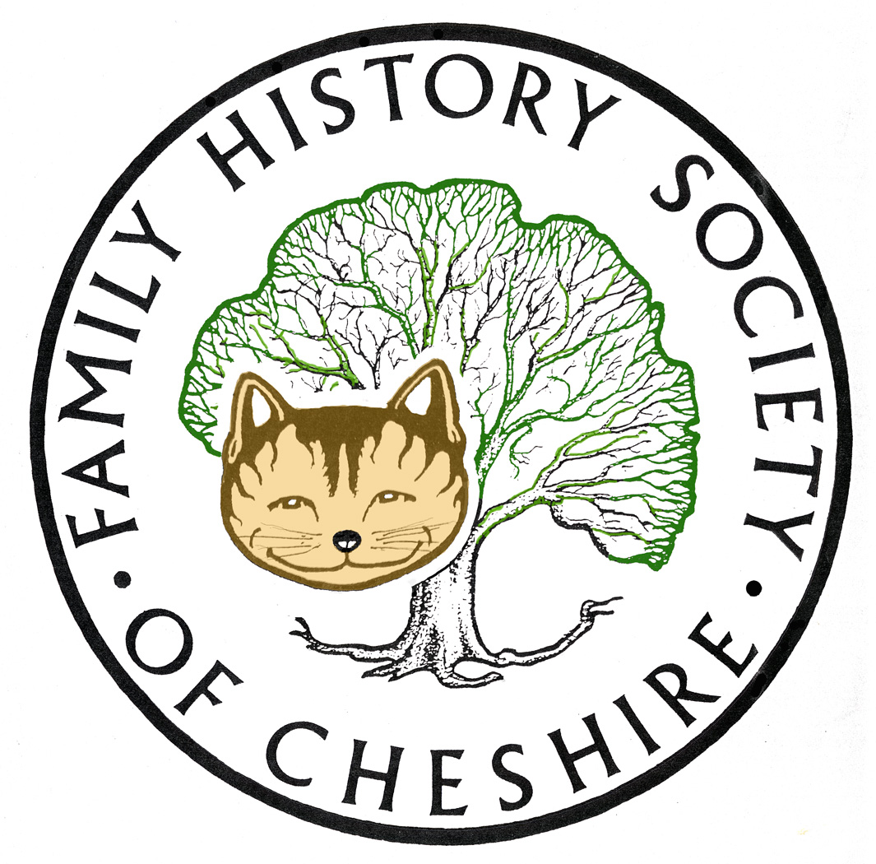
TAMESIDE GROUP NEWSLETTER
August 2017

Who Do You Think You Are
The second episode about Craig Revel Horwood, led to the discovery of his ancestor Harry Macklin Shaw from Ashton-under-Lyne who became a champion clog dancer. The episode didn’t mention much about his past in Ashton except his birth in 1840. I had to search a little more to see what I could find out. He married Mary Ann Hopwood under the name of Michael Macklin, at Stayley St Paul’s Church 1862, and emigrated a year later on his own. No further mention of his wife and a name change to Harry Macklin Shaw.
After a break for the World Athletics a further five episodes should start next week with Lisa Hammond, Noel Clarke, Lulu, Fearne Cotton and Ruby Wax.
Interesting photo of the first journey on the London Tube, 28 November 1861:
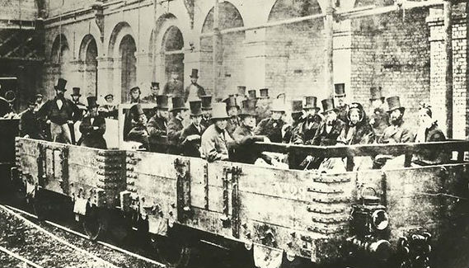
Proposed Trips
I am absolutely delighted to say that David Mason has agreed to become our trip organizer and the following is what he hopes to organize for us:
Clayton Hall, Clayton, Manchester

Clayton Hall was originally built in the 12th century for the Clayton family later becoming the home of the Byron family who sold it to George and Humphrey Chetham, founder of Chethams School and Library in Manchester.

Some rooms are dressed to offer a glimpse into Victorian life. There is a café and gift shop in the building. There is no lift to the upper floors so access is by staircase. Getting there is easy as it is on the 216 Bus, and Tram routes, although no car park you can park in the side streets (pay attention to restrictions).

It can be arranged for a group visit so if you are interested please let me know.

Imperial War Museums North (IWM)

The IWM is situated at Salford Quays, easy to get to by car, bus and tram. Apparently the tram is planned to go straight to IWM but not yet so go to Media City and walk across the foot bridge.

The Museum is free although there are some areas that have an admission fee. There is lots to see and do and places to eat. The Big Picture Show (3 themed presentations) with 360° images sounds very interesting.

If you are interested in going as a group please let me know as we may be able to organise a group visit. What day is best for you, is a Friday a good day? More information will be given when we have decided where and when to go.

If you have and other suggestions please let me know I can then do a little research into possible group visits.
Cheers
David Mason

Registering with our Website and opting to receive these newsletters

Many of our regular visitors are still not registering with our website and may not get this newsletter in future

You don’t need to become a member of our society to have some advantages of registering with the site. As a registered website member, you can add the surnames you are researching in Cheshire and search our database. You can also choose to receive newsletters from any of our groups and be able to attend meetings and our research centres at visitors’ rates. Visit our new website at: https://www.fhsc.org.uk click on MEMBERSHIP OPTIONS and then WEBSITE USER.

Once you have registered you can go to any of our group pages and choose to follow those groups. This will mean you can also receive these newsletters from and other areas of Cheshire you are interested in. Please note that if you decide to become a Registered User and not a full member, you must go to our Tameside Page and click to add yourself to our group to continue to receive this newsletter.

DON’T FORGET THAT BOTH FINDMYPAST AND ANCESTRY.COM ARE AVAILABLE TO USE FOR FREE AT TAMESIDE LOCAL STUDIES AND ARCHVES LIBRARY and that we have volunteers there helping people on the first and third Tuesday afternoons each month. You don’t have to be a beginner come along and see if we can break down that brick wall.

Programme 2017

September 13 – AGM plus Dating Old Photographs – Gay Oliver

Our AGM should only take about 20 minutes and then I hope to deliver the presentation I did to my peer group during teaching practice. Mostly concentrating on the history of photography and how to date Victorian and Edwardian photographs

October 11 – Cathryn Booth the mother of the Salvation Army – Danny Wells
Catherine Booth (nee Mumford) was fortified with the spirit and convictions of early 19th century rural Methodism of the Midlands. Having met a kindred spirit in William Booth of Nottingham, they were to take their pre-industrial Methodist creed into the religious and political fulcrum of the East End of London in the second half of the century.
The response of the Booths to the poverty, hunger, squalor and ‘sin’ that they observed all around them, was to create the Salvation Army as a ‘Way out of Darkest England’. It became the fastest growing religious movement of late Victorian Britain and remains a religious and social service agency of international significance to this day.
Despite suffering from poor health throughout her life, Catherine raised eight children; developed a deep and profound knowledge of Christianity; proved to be a renowned orator and powerful advocate for her faith, and showed tremendous drive and fight in the founding and development of the Salvation Army. Have the 20th and 21st centuries neglected the achievements of this indomitable woman? Jean Laidlaw, Macclesfield Group Leader

November 8 – Lynne Quirke – The Cotton Famine.

Recommended by Denton Local History Society. Lynne has spoken to their group and has also published books. She has spent a few years researching the Cotton Famine

December 13 – Christmas Social

I think I have managed to source someone to deliver ready heated pies to our group, which should save so much time and effort for our volunteers in the kitchen on the evening. We should have our usual raffle and I will be seeking suggestions for our entertainment for the evening.

January 10 – Some Local family Histories – Gay J Oliver, I will be charting the family histories of several of the more famous people buried in Dukinfield Old Chapel graveyard. These include:
- John Armitage who went to Brazil to form part of the legislature there and wrote the History of Brazil.
- Some of the Dukinfield Family members who became involved in the Slave Trade.
- Kate Bradbury an Egyptologist who worked with Flinders Petrie,
- The Beatrix Potter connection,
- Links to William Gaskell and John Gaskell Minister of this chapel
- The Stanley Family’s involvement with the Prophet\Charlatan John Wroe and Early Islam in this country
- The Cheetham Family – Millowners and Philanthropists
February – No Meeting Chapel Pantomime

March 14 – TBA

April 11 – Gillian Rossini – Family History on a Budget or Illegitimate or Adoption

Gillian has been speaking to groups for 30 years and has written several books. She has a list of talks and the two above looked interesting for our group

May 9 – Kate Booth – the Spanish Flu - 100 years ago

Just as War was coming to an end, a world pandemic was raging and killed more people worldwide than the recent war. The flu epidemic was a type of avian flu but called Spanish Flu because that is where it was first reported. Her talk includes some local families affected.

June 13 – Peter Braun – The Monarchy and Dunham Massey

A review of an illustrated talk about the Hall and its occupiers recently given at Bolton FHS Group. Wow! What an understatement this was. I think Peter was really giving us a “potted version” of his routine when guiding groups around, so he started from outside showing us how there have been 3 buildings from 1616, 1650, to1730. He then told us stories of the Booths who had lived there from the 1400s, but after 350 years they were succeeded by the Greys who took over in 1770 by marriage, and who managed the house and estate for another 200 years until 1976 when the 10th and last Earl, Roger Grey died. We heard of royal and political intrigue linking Edward 1Vth’s descendants via Elizabeth Woodville to the facts behind the “Princes in the Tower” incident (who had been two of the couple’s children guarded by step brother Thomas Grey who had been removed and killed).

Lady Jane Grey was another descendant. George Booth who was involved with the build up to the 17thC Civil Wars. Thomas Grey’s signature was on Charles 1st execution order, second only to the senior judge John Bradshaw and before Oliver Cromwell’s. Memories were long, especially re royalty, and it seems likely that the willingness to sign the king’s death warrant stemmed from incidents 90 years previous related to Jane Grey. By now I think most felt they were whirling around in a fast track TV drama which was for real. We knew most of these stories but had never related them to each other. Architects were mentioned such as John Norris and Joseph Crompton Hall and the reshaping of the building through the ages.

The grand finale was probably the story of how the direct line died out but was retrieved via a distant cousin living in South Africa, the 8th Earl of Stamford, a missionary Bishop who was enjoying many “liaisons”. The Stamford lineage died out in 1976 with the death of the 10th Earl. Today, Dunham Massey is a tourist attraction owned by the National Trust.’

July – Visits tba arranged see proposals by David Mason mentioned above.

August – no meeting

September 13 - AGM and Ancestry versus FMP Comparison

October 11 - TBA or I could talk about the Murphy Riots of 1868 in this area.

About four years ago I had access to the home Office papers concerning these riots. What led up to them, the signing up of special constables and telegrams going back and forth to the Home Office requesting help etc. I’ll leave it up to the group whether they want me to develop this into a talk and presentation.

November 8 - Sex and Sin in 17th Century Lancashire – Alan Crosby

Alan is a national speaker and writes for the WDYTYA Magazine

Dr Crosby said that there was great emphasis on puritanism and morality in the 1600s and documentary sources were abundant. Serious crimes meriting the death penalty were dealt with by the Assize court in Lancaster. Lesser crimes went before the Quarter Sessions held at Epiphany, Easter, Midsummer and Michaelmas originally in Lancaster and Preston and later in other towns including Ormskirk and Wigan. Church courts dealt with crimes reported by the churchwardens and punishments were excommunication or public humiliation.
Quarter Sessions records are a rich source of information regarding sexual misconduct, bastardy and the operation of the poor law. Unmarried mothers were encouraged to relocate to a neighbouring parish before giving birth, interrogated (even in labour) to reveal the identity of the father so that a maintenance agreement for the child up to age 14 could be enforced. Women were sent to a house of correction for three weeks or more and soundly whipped. Dr Crosby read numerous examples.
Divorce was dealt with by the Church courts in cases where there were no formal documents. Annulment could be granted on the grounds of non-consummation, consanguinity or a technical difficulty.
Review by Ormskirk District Historical Society 2012

December 13 – Christmas Social

I have a couple of ideas waiting to be confirmed to fill the gaps and will let people know as I confirm dates. If anyone has been to an interesting talk recently please get in touch

Gay Oliver: gayjoliver@gmail.com 8 August 2017

