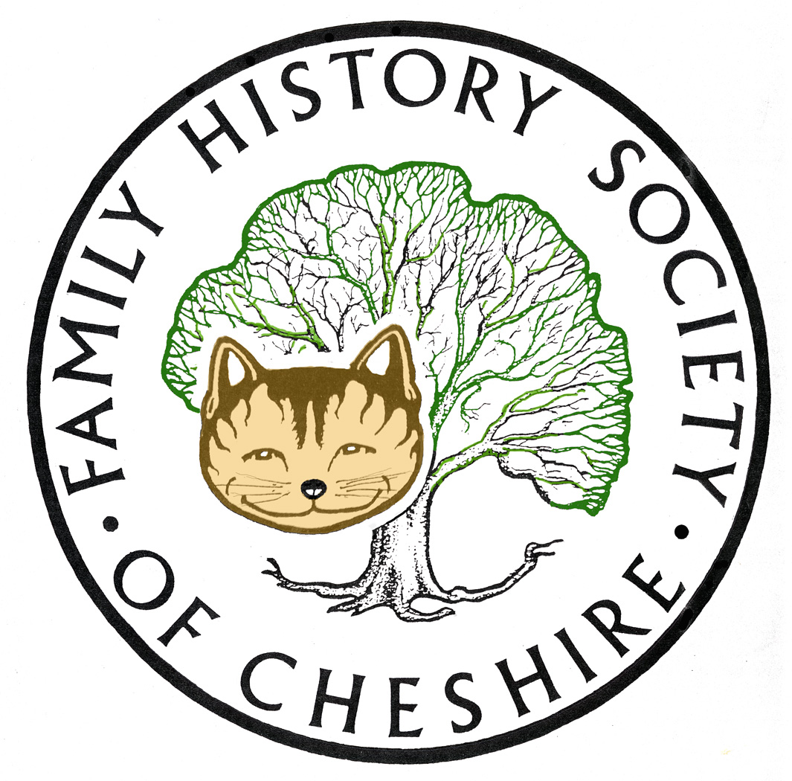
TAMESIDE GROUP NEWSLETTER
April 2016

Apologies:

Sorry I’ve been rather late with everything this month, but I had an accident and a vile chest infection at the same time, nearly better now.

NEED VOLUNTEERS TO TAKE OVER REFERSHMENTS:
Pat will be giving up providing refreshments at our meetings, so we need to find someone else to take on this role. Will talk about it at the next meeting and try to make it as easy as possible for the next person taking over.

Our New Society Website is Nearing Completion:

I have had a last minute cancellation for our April meeting and Tony Bostock will now be coming along in May. The space freed allowed me the opportunity to demonstrate our new website. The website will have benefits for both members and non members. The site will be more interactive and eventually will make it much easier to join and buy things directly on-line, to add your research surnames and for members an exclusive section about the benefits available.

Reminder to subscribe for the Lost Cousins Newsletter:

Really is one of the best newsletters to sign up for. It’s totally free and very informative: http://lostcousins.com/newsletters2/midapr16news.htm

UKBMD Project:

Press Release for immediate release from the Local BMD Project - Free Online Tutorials
Over the years I've had the honour to talk at a variety of Family History Society and U3A group meetings on the subject of "BMDs on the Internet", offering an introduction and advice on how to get the best out of the various BMD websites that are part of the Local BMD Project. I've now split my talk up into a set of separate video tutorials which can be accessed, for free, via the UKBMD website. Full details about the contents of these tutorials can be found on the Tutorials page. http://www.ukbmd.org.uk/tutorials

Local Events:

Please have a look at our Local History Forum website: www.tamesidehistoryforum.org.uk

Including:

Please read about the plans this year for the 150 anniversary of Beatrix Potter by the Friends of Gorse Hall.

Visit To St Helen's Glass Tuesday 17th May 2016.

The latest programme of talks for Tameside History Club.
'Women's Suffrage-1911 Census in Ashton' the talk is given by Alice Locke. at Ryecroft Hall 7.15 pm Monday 23rd of May 2016. All welcome, please come in and learn the history on your doorstep. Non members £2 entrance.

__________________________________________________________________________

Reprieve for Family Tree Maker leaving this announcement up for the second month running

Ancestry made the following announcement to users of Family Tree Maker™ in early February 2016
Since our Family Tree Maker announcement last December, we have continued to actively explore ways to develop and support Family Tree Maker and ensure you have choices to preserve your work in ways that matter to you. Today, we are pleased to announce two options for desktop software that will work with Ancestry.
MacKiev
Software MacKiev, with whom we have a long-standing relationship, is acquiring the Family Tree Maker software line as publisher for both Mac and Windows versions. Software MacKiev has been the developer of Family Tree Maker for Mac for more than six years and is thrilled at the opportunity to publish future versions of Family Tree Maker for Mac and Windows.
This new agreement means you will receive software updates and new versions from Software MacKiev, and have the ability to purchase new versions of Family Tree Maker from Software MacKiev as they are released. You will have continued access to Ancestry Hints, Ancestry searches, and be able to save your tree on Ancestry with Family Tree Maker moving forward.
RootsMagic
We have made an agreement with RootsMagic, a leading genealogy desktop software program publisher, to connect Ancestry with the RootsMagic software by the end of 2016. With this new relationship, RootsMagic can serve as your desktop family tree software, while having access to Ancestry hints, Ancestry searches, and the ability to save your tree on Ancestry.
We have heard your concerns and are working to provide the solutions you requested. These new agreements will make it possible to preserve your work on Ancestry and Family Tree Maker and enable future features and benefits to help you discover your family history. Be assured that Ancestry, in cooperation with Software MacKiev and RootsMagic, will continue to support you as you discover your family history.

We ask for your patience as we work diligently through all the details to make these solutions available. You can find additional details about these Family Tree Maker partnerships on our blog. We also encourage you to continue to check back on our blog for future updates in the coming months.

New Collections at Ancestry the main new collection since my last newsletter is a whole set of Parish registers for the Isle of Man. Keep an eye on their latest additions page for more: http://www.ancestry.co.uk/cs/recent-collections

Find My Past:

I recommend everybody keeps up-to date with their collections by following their blog: https://blog.findmypast.co.uk/

Programme for 2015 - 2016:

May 11 – Tony Bostock “My Genealogical Journey”.

June 8 – Gordon Adshead – “My Stalybridge Adsheads and how a One-Named Study Helped”.

July – visit Stockport Hatworks?

August 10 - Possibly our Local History Group about their research project: Cockbrook.

September 14 - AGM

Gay Oliver: gayjoliver@gmail.com 17 April 2016

