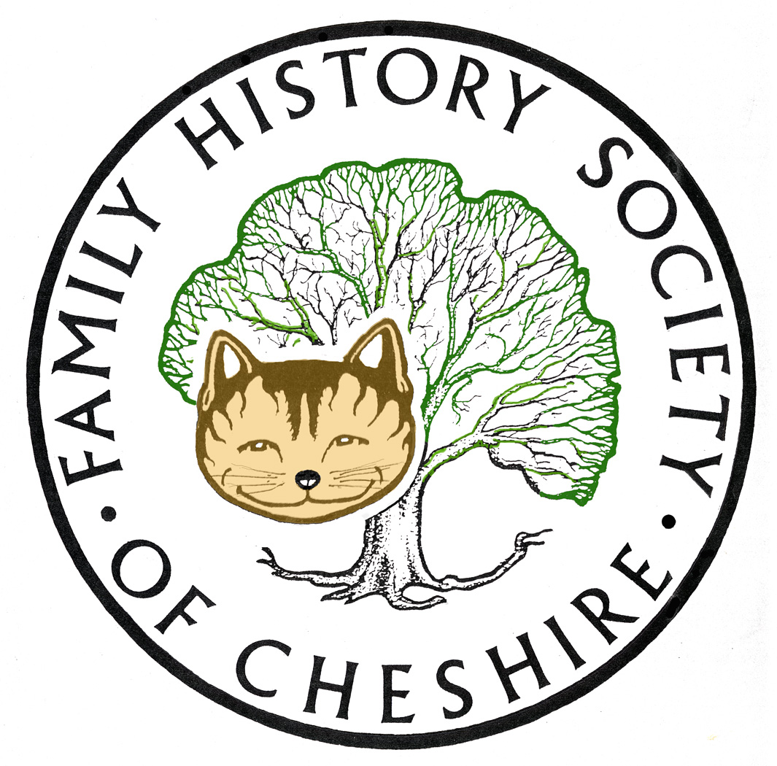
TAMESIDE GROUP NEWSLETTER
April 2014

We still need occasional volunteers
Thank you Jenny for volunteering to stand in when Pat can’t make it, but I do need one or two new volunteers or even three or four in view of a couple of events below.

Our Society Family History Fair to be held on 10th May at Ellesmere Port. So far I have two people to help on the day, but also need at least one other to help to look after our stand. There are some excellent talks planned for the day Please see the poster attached.
Members’ Day 18th October It is Tameside’s turn to host our AGM and Members’ Day this year. I have booked Stalybridge Methodist Church as our venue and so far have four people who will help during the day, but I am going to need another six or so people to help in the kitchen on reception, manning a stand and generally greeting and helping our visitors from all over Cheshire, and many people to contribute some home baked goodies for refreshments. The day will consist of two talks (I haven’t booked the speakers yet) and perhaps a guided walk. The business of the AGM usually only takes about half an hour just before lunch. I am also planning to have a word with the Wharf Tavern opposite to lay on some food for those who don’t want to bring a packed lunch. PLEASE HELP ON THE DAY. This is the first time Tameside will be the host.
More details as we get nearer the time.
New Society Website Alan Bennett and I have been working many, many hours over the last six or so weeks towards the launch of our new website. This has become necessary because our host would not be supporting the old platform for much longer. I had hoped it would be launched in time for tonight’s meeting, but there has been a delay due to illness. I must say that so far I am impressed with the functionality of the new site which will offer much more interactivity for our members and a shop to order items on-line and pay via paypal.
Last year Family Search moved over to a new website and people were lost at first because they preferred the old site with the ability to get straight to searching the IGI, but now I feel most people have got used to using it and all the new records which have become available. They have also changed their policy regarding copies of any film books etc to be emailed direct on request. This a FREE service: http://bit.ly/1e8E6og
A few weeks ago Ancestry finally switched off OLD SEARCH so we are going to have to become used to using their sliding filter bars, but at least we were warned and I had been trying to get used to their NEW SEARCH for some time now.
But this week Find My Past seem to have upset the whole family history world!!! Without warning they switched overnight to their new platform. It was embarrassing at our help desk in the Library this week. It has become dubbed as Can’t Find My Past or Lost My Past. I am slowly getting used to it, but this change could not be more different from the old site. Admittedly they are trying to change things to take on the multitude of complaints. They will have to or they will lose customers. The following is from an email I received last night from our Computer Group Leader:
‘The e-mail exchanges from last week have inevitably raised a lot of comment. It's very evident that FMP have got themselves into very deep water, but it's also evident that they are working very hard to try and correct the mess that they have created.
If you want to see what the world thinks about the mess do please go and have a look at the forum on this link:
http://feedback.findmypast.co.uk/forums/222583-ideas-and-improvements/suggestions/5649598-improve-features-to-bring-in-line-with-the-old-sit?page=1&per_page=20

I've done enough research now to enable me to find ways around the more significant problems that I encountered. It's evident that they are making numerous improvement changes daily, and probably hourly. In this situation I propose, and recommend, that we leave them to get on with it for a week or so. Here are some of the ways that I have found myself able to conduct the sort of BMD and Census searches that I’m used to:

• If you go to the Home page and select Search Records, then List All UK Records you can see the key groups of desired searches, such as BMD and Census. At the bottom of the list you will also find the Special Collections.

If you follow the links from Births and Baptisms then Births and Baptisms again you get to a Records In This Collection box which contains Births 1761-2006. Clicking on that leads you to a further page upon which you should find England & Wales births 1837-2006. It's quicker to do than write/read!
The point of amusement is that once you gain access to the search page there are no fields completed and it therefore tells you that you have some 133 million results starting with Elizabeth Abbott! That's presumably all records in the collection, and you can then see how their new method of 'Filtering' is applied to bring the search down the person you are looking for. As an exercise try searching for your own birth record. As you add your name, birth year, mother’s maiden name, you can see how the selection is `filtered down’ and develops.

• In a similar way if you select Census from the UK Records list, you are quickly led to the regular list of UK Census data. In selecting a specific year, you then get taken to a full comprehensive search page which incorporates everything that used to be seen in the old category of Advanced Search. It's a long form and annoyingly the Search button is at the bottom, but it does work!

It's my view that what we want to see is all there but they have completely screwed up the access paths. They know that they’ve screwed it up and commercially they know that they've got to fix it. As said earlier I propose to sit back and wait for a couple of weeks.”

After all the moans they did announce this a few days ago: New project to release the 1939 Register for the first time online: Findmypast is thrilled to announce a new project to release the 1939 Register, which will see 40 million wartime British records published online within the next two years. In the most anticipated family history development since the 1911 census, findmypast are working in association with The National Archives to provide the only complete overview of the population between 1922 and 1950.

New Map resources:
http://maps.nls.uk/ the National Library of Scotland has released a whole series of OS maps for England. Click on SERIES

Tithe Records at http://www.thegenealogist.co.uk/news/#latest
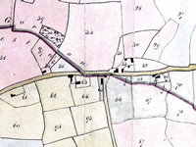
MAJOR NEW RELEASE:
At Who Do You Think You Are? Live, TheGenealogist launched ‘The National Collection of Tithe Records’ in an exclusive partnership with The National Archives. For the first time you are able to search over 11 million records and view the original documents online.
The Tithe Records provide a unique view into our ancestral heritage by providing details of ownership and occupancy of land throughout England and Wales, revealing a wealth of information about people, places and landmarks in the Victorian era. The Tithe Commutation Act of 1836 meant records were taken, as with the Doomsday Book, of the land ownership and occupancy, land uses and sizes, and the rents to be paid.
Tenants and landowners from 11,000 parishes across England and Wales are featured in the records. This provides the opportunity to discover whether your ancestors were landowners and how their land was put to use, or if tenants or occupiers, which plots of land they were living or working on.
The GAZETTE
Another website undergoing a metamorphosis is the Gazette and this time I totally approve: https://www.thegazette.co.uk/ Give it a try really works well.

This is interesting; it is the history of our world in two minutes put together as a student project:
http://marcbrecy.perso.neuf.fr/history.html

Jean Laidlaw, your Journal Editor is preparing a special edition of Cheshire Ancestor for next September. She has asked the Committee to pass the word down-the-line (there’s a bit of WW1 jargon!).
Please read the article in the December issue of the Ancestor or visit our website for more information. Please give this matter some serious thought – and preferably some action! There are five months to the deadline, but why not start drafting it now. `Your Society Needs You’ Note that there’s a competition for pieces judged to be the best article.
Ashton Grammar School World War One Memorial:
I have been researching the names of the students and a teacher listed on the Memorial. This was for a proposed Heritage Lottery Bid to have the memorial renovated and for Ashton Sixth form to turn their stories into a drama. Several partners were involved in the bid and we are pleased to announce that we have won funding. Eventually they also hope to turn the drama into a film to show at Portland Basin. I handed over details of my research January. The Drama is now taking shape and there will be two promenade performances at Portland Basin Museum on 3rd July along their 1920 street which has been converted to Wartime. There will also be an exhibition running for six months from the end of June.
Tameside Family History: I spent all last Saturday up-dating my own family history website, so please take look at the latest up-dates: tamesidefamilyhistory.co.uk/latest.htm
YDNA TEST I have had the results of my brother’s YDNA test, which have come as a bit of a shock. I had built up the romance that my CULLEN Irish Ancestors were from Southern Ireland and were the Celts who might have built New Grange. The very day the results came through I was contacted by a man called KEN PARKS in America who is a direct match He also runs the PARKE SOCIETY DNA project. It turns out that our little group of PARKS belong to a small sub sample predominately of Norman/Norse origin and the PARKS may have come to Northern Ireland from Scotland during the 16th or 17th century migration to the Ulster Plantation. I am now trying to pinpoint which of my grandmother’s didn’t have a baby with a CULLEN and who the PARKS intruder is. Fascinating. The oldest proven progenitor of our direct match was a Thomas PARKS born in Pennsylvania in 1760

Programme for 2013 - 2014:

May 14 – John Titford ‘Barking up the Wrong Tree’ author of several family history books, will be explaining how easy it can be to 'bark up the wrong tree' using examples.
June 11 – Kathryn Booth ‘An Inventory of War Memorials in Tameside’
In the meantime we need to try and arrange a trip and tour of the New CENTRAL LIBRARY I will also be starting to organize our programme for next year soon, so IDEAS PLEASE!!
July Trip to the Imperial War Museum North still to be arranged
Any changes or alterations to our programme will be posted on our Society website: fhsc.org.uk click on Groups and then Tameside. Meetings are held in the Old Chapel schoolrooms, Old Road, Dukinfield, on the second Wednesday of each month (except August), starting at 7.00 pm. £1.50 for members and £2.00 for non members, tea and coffee on arrival.

Our Local Committee will be meeting on 30th April mainly to discuss future events, but also the purchase of new equipment. We do have the money but buying a new laptop and projector is going to cost quite a bit. The projector was bought in 2002 (ancient in technology terms) and the netbook in 2007. The netbook still runs on Microsoft XP which is not longer supported from this month. Both these items have started to fail, so we do need replacements. I will let members know what we decide.

Gay Oliver: gayjoliver@gmail.com 8 April 2014

