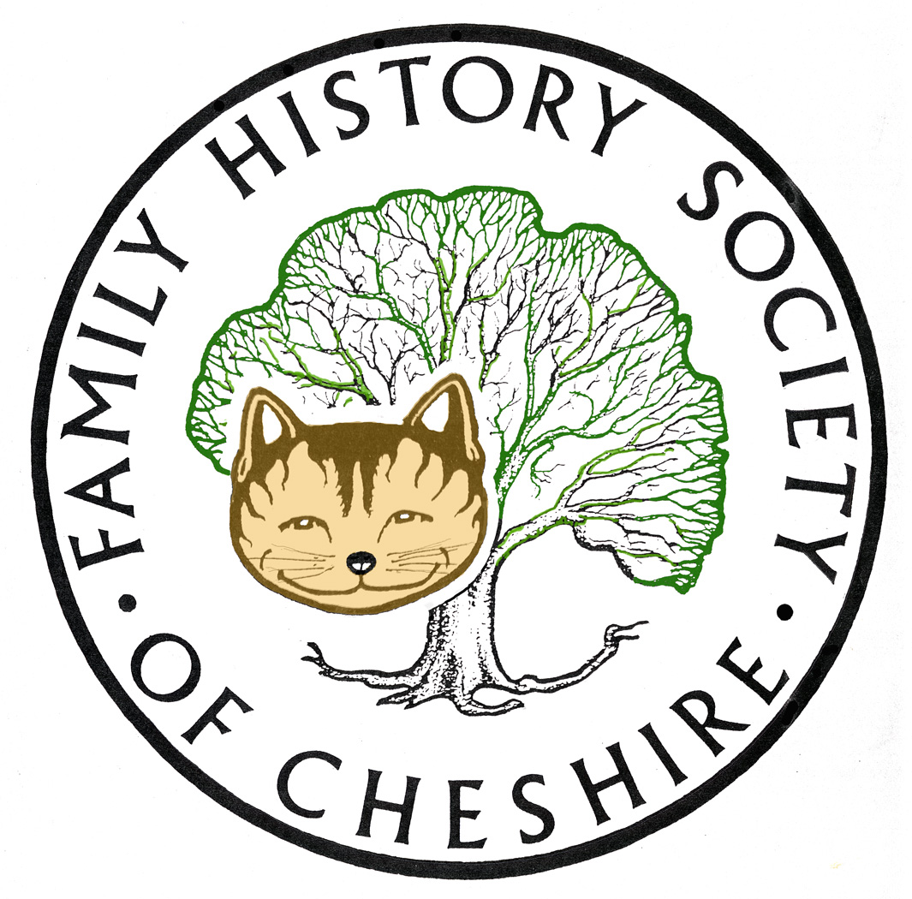
TAMESIDE GROUP NEWSLETTER
April 2013

NOW IS THE BEST TIME TO JOIN OUR SOCIETY: Joiners in April get 15 months membership for 12 months cost and five editions of the Cheshire Ancester. Come and look at some sample editions of the Ancestor and ask me for membership forms also please remember to Gift Aid. Societies are beginning to struggle and Gift Aid lets us claim back an extra 20% from the government at no cost to you.

Grave undertaking as Manchester's Victoria Station cemetery is departing from Platform 1

Cholera Victims from Walker’s Croft are to be dug up whilst building work progresses at Victoria Station. Any bones will be exhumed put in coffins and reinterred at Southern Cemetery. Read more here: Manchester Evening News http://bit.ly/16LCQOo

Welsh Newspapers go on-line: Several of the Welsh mailing lists have had messages about the launch of the BETA version of Welsh Newspapers Online. It might be of interest to some of you, particularly the North Wales newspapers. http://welshnewspapers.llgc.org.uk/en/home

Research Project about Convicts Transported to Tasmania Founders and Survivors is a partnership between historians, genealogists, demographers and population health researchers. It seeks to record and study the founding population of 73,000 men, women and children who were transported to Tasmania. Many survived their convict experience and went on to build a new society. By examining birth, death and marriage records and other historical sources, the project will produce the means of analyzing the health and welfare of Australians over 200 years: http://www.staff.utas.edu.au/news/articles/our-biggest-family-history-underway

Ancestry - 500,000 Wiltshire marriages online have made available over half a million marriage transcriptions covering all 327 Wiltshire parishes, and including a handful of records from 1538, when parish registers began (the most recent entries are from 1837).

There are no digitised images of the registers, and unfortunately it's not clear which entries have been taken from the registers, and which from Bishop's Transcripts or other historical transcriptions. As is the case with many transcriptions, the names of marriage witnesses aren't included. If you don't have an Ancestry subscription I'd suggest starting with the IGI, as a lot of Wiltshire baptisms and marriages are included. You'll find details of the IGI coverage here.

Find My Past: have added 650,000 more pages from British newspapers, so there are now 6.5 million online. You'll need a Full or World subscription to view them

Cheshire BMD: Another up-date - Births Replaced 9,688 for Audenshaw, registers at Tameside (1937-1951) to add mother's maiden name. It won’t be long now until all the mothers’ maiden names are complete to 1874

Programme for 2013:

8th May – Dr Susan Deal ‘Cleanliness is Next to Godliness’ the Victorian Obsession with Hygiene.

12th June – David Lambert, member of the Metcalfe Society will be coming along to let us know how belonging to a One Named Study Group has helped with his research.

July – I am suggesting a visit to the working Cotton Mill at Queen Mill in Burnley or Lancashire Record Office.

I have also already booked one speaker for November 2013 – John Creer will be coming along to talk about DNA and Family History.

Any changes or alterations to our programme will be posted on our Society website: fhsc.org.uk click on Groups and then Tameside. Meetings are held in the Old Chapel schoolrooms, Old Road, Dukinfield, on the second Wednesday of each month (except August), starting at 7.00 pm.

Gay Oliver: gayjoliver@gmail.com 9 April 2013

