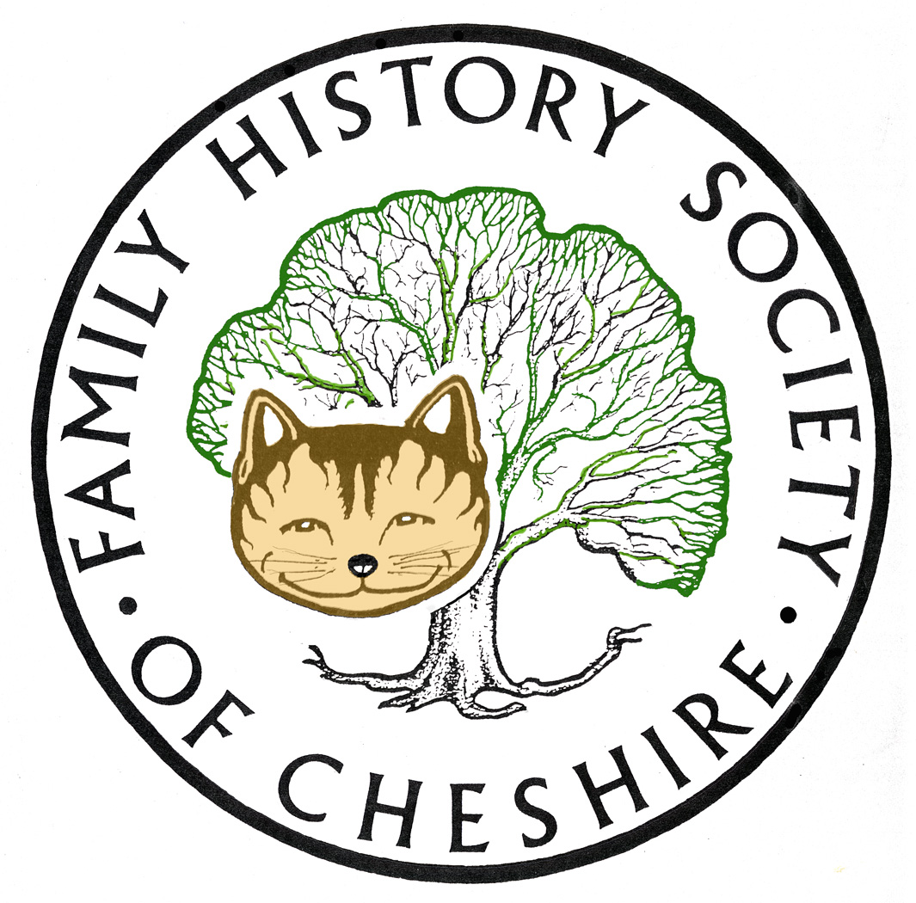
TAMESIDE GROUP NEWSLETTER
November 2014

‘ Due to serious illness amongst our Group Committee, I will be needing need occasional volunteers‘

New Society Website working hard again on the launch of our new website.

*Tameside Local Studies and Archives Library is closing Wednesday 19th November for at least 4 weeks and not likely to reopen until sometime in January. Part of the main room is having to be partitioned off to make offices to accommodate staff from the Council Offices Culture team*

Following on from our meeting last month Adrian sent me these links:

This is the link to the BBC Domesday Reloaded Project: http://www.bbc.co.uk/history/domesday , within which there is a link to the National Archive Domesday Book records: http://www.domesdaybook.co.uk – via “Story of Domesday”, scroll down to “Elsewhere around the web” and click on “1086 Domesday Book – online”.

Find My Past: Have now added a page to my website with a reminder about my suggestion to search their rejigged website: tamesidefamilyhistory.co.uk/fmp.htm Also keep an eye on this page for more: http://blog.findmypast.co.uk/

Ancestry: Have just added their Lancashire Collection this month and up-dated lots of Military information visit their new collections website for details: http://www.ancestry.co.uk/cs/reccol/default and click on United Kingdom in the drop down menu. Many records added since my last newsletter.

World War One projects in Tameside: I have been gathering them altogether on a page on the History Forum’s website: www.tamesidehistoryforum/org/uk/ww1.htm I mentioned this at our last meeting, but if anyone wants to add anything to this page please get in touch.

Irish BMD’s well these did become searchable on-line – briefly – and then were removed due to privacy and fraud concerns. I have since heard that they will become searchable online again soon, but with closures on more recent records. Have read recently that they will reappear, those over 100 years for births, 75 years for marriages and 50 years for deaths.

New website: http://www.battlegroundtours.co.uk/ Our speaker this evening has also started a business this year taking people round the battlefield sites.

Namenerds: A new site I have found about forenames and their meanings: http://www.namenerds.com/

Redcross First World War volunteers: over 90,000 people volunteered for the Red Cross at home and abroad. Personnel records for surnames A and B are currently available. Volunteers are updating the site with more names every few weeks.
http://www.redcross.org.uk/About-us/Who-we-are/History-and-origin/First-World-War

Next Month: We will be having a raffle and a potato pie supper. So the charges for the evening will go up for this month only £3 for members and £4 for guests. Sid Calderbank is a very entertaining speaker so it should be an excellent Christmas Social.

Programme for 2014 - 2015:

November 12 – Nigel Dunkerley, “Conscientious Objectors and Excepted Occupations”

December 10 – Sid Calderbank, “A Reet Lanky Evening” and Potato Pie Supper

January 14 – Anne McGarry, “The Girls Who Walked Away”

February – visit possibly to Police Museum

March 11 – Peter Park “A Bomb in My Back Garden”

April 8 – Tony Foster, “A Deeper Look at Civil Registration”

May 13 – Peter Higginbotham, “Children in the Workhouse”

June 10 – Me – Poor Law in Tameside

July – Trip possibly to Liverpool Archives and Museums on the Waterfront

Any changes or alterations to our programme will be posted on our Society website: fhsc.org.uk click on Groups and then Tameside. Meetings are held in the Old Chapel schoolrooms, Old Road, Dukinfield, on the second Wednesday of each month (except August), starting at 7.00 pm. £1.50 for members and £2.00 for non members, tea and coffee on arrival.

Gay Oliver: gayjoliver@gmail.com 12 November 2014

